**OFD User Manual**

**1. System description**

**1.1 Introduction to the system**

The system is mainly aimed at ofd type documents, and can realize basic operations such as opening, editing, commenting, and marking of documents. On this basis, from the perspective of privacy computing, the privacy control of ofd documents is carried out from the generation, perception, publishing, dissemination, storage, processing, use, and destruction of ofd documents.

**1.2 A PP installation**

**1.2.1 Receive and install from WeChat**

After receiving, click "Open with third-party application", as shown in Fig.1-1 below.

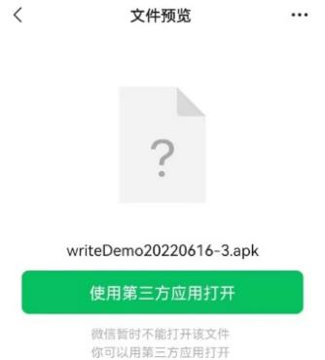

Fig.1-1 Receive apk

Click "Continue Installation", as shown in Fig.1-2 .

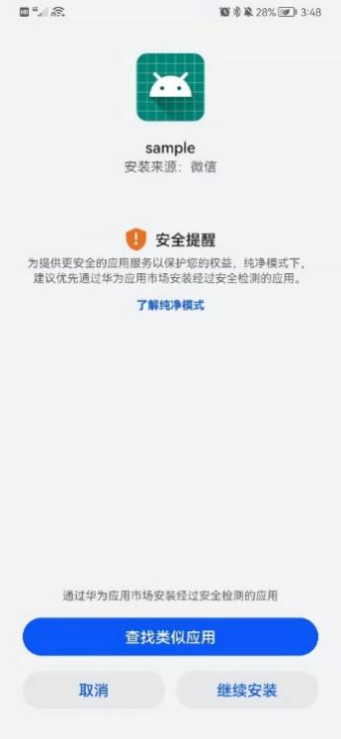

Fig.1-2 Continue the installation

Next, go to [Settings] -> [Apps and Services] -> [Permission Management] -> [Apps] -> search for "sample" to give all permissions.

**1.2.2 Find the apk and directly import it and install it**

To the address of the apk, such as [File Management] -> [My Phone] -> find wirteDemo20220616-3.apk, click it, the interface shown in Fig.1-3 will appear, click "Continue Installation".

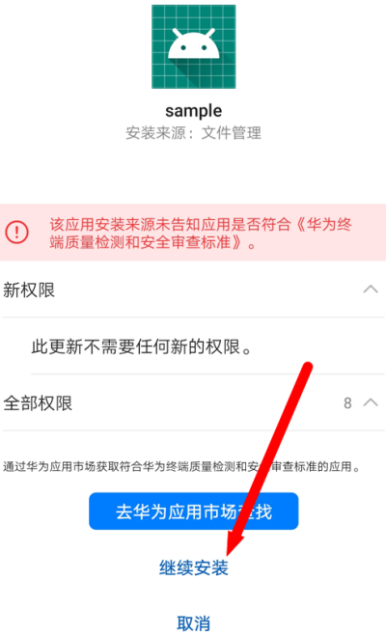

Fig.1-3 Continue the installation

Next, check all permissions, as shown in Fig.1-4.

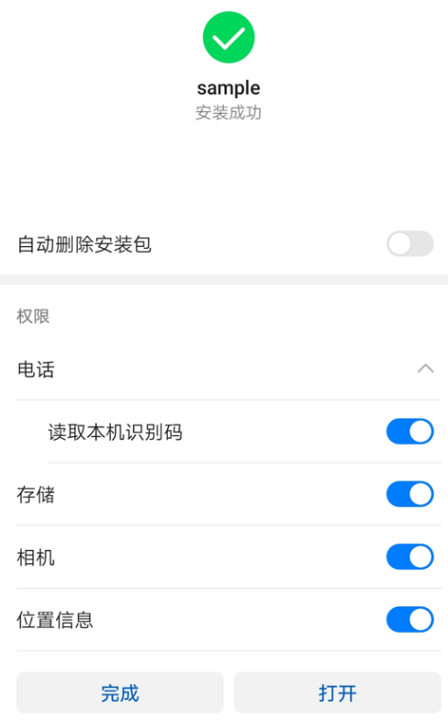

Fig.1-4 Confirm permissions

**2. User operation**

**2.1 Language selection**

When users use the APP for the first time, they need to set the default language of the APP. The interface is shown in Fig.2-1. The supported languages include Chinese and English.

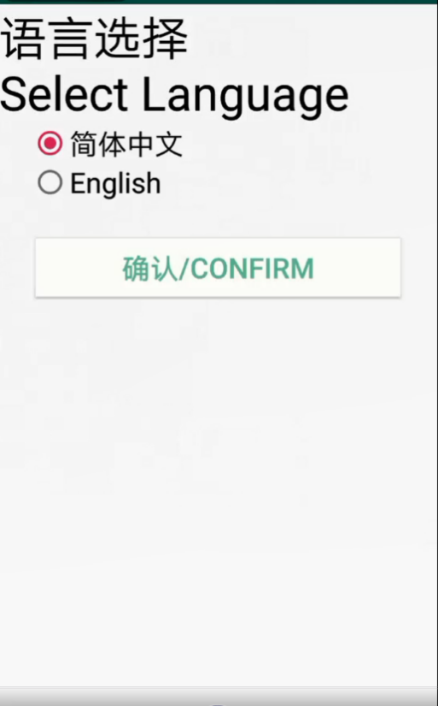

Fig.2-1 Language selection interface

**2.2 User registration**

Before using the APP, users need to register first. The registration interface is shown in Fig.2-2. The information that the user needs to fill in during registration includes: user name, password, email, mobile phone number, ID number, organization and avatar.

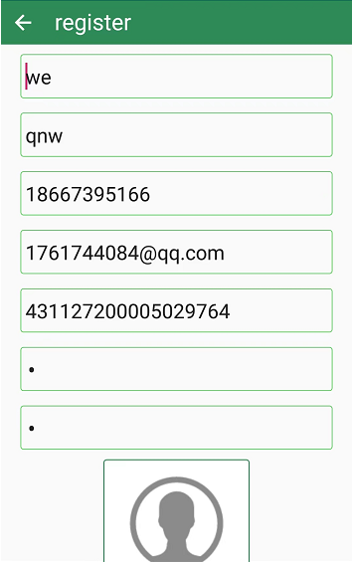

Fig.2-2 User registration interface

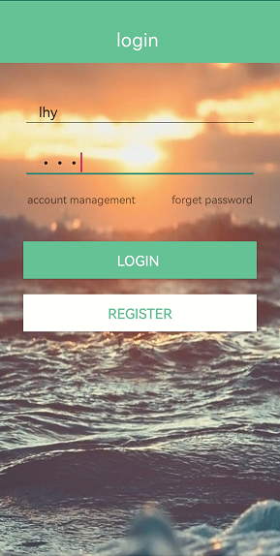

Fig.2-3 User login interface

**2.3 User login**

When logging in, the user needs to fill in the user name and password bound during registration. The user's login interface is shown in Fig.2-3.

**2.4 User level setting**

Users can adjust their permission level at "My" -> "Permission Level", as shown in Fig.2-4. The user's permission level will be used later to determine whether the user can open a particular document. The setting interface of permission level is shown in Fig.2-5.

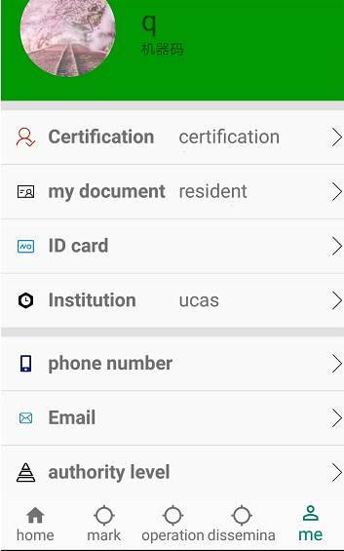

Fig.2-4 Permission level setting method

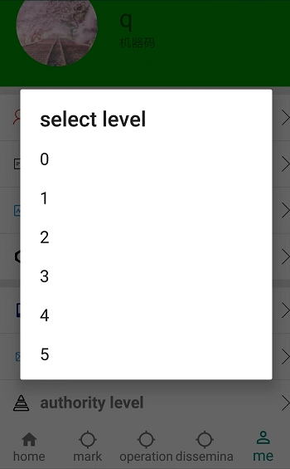

Fig.2-5 Setting the permission level

**3. Labeling**

**3.1 Position constraints**

**3.1.1 GPS constraints**

GPS constraint refers to setting whether the file can be displayed or not by filling in the latitude and longitude coordinates as the center of the circle and filling in the radius as the effective range of the circular area. As shown in Figure 3-1, the user can click the "Fill in current location (GPS)" button to fill in the current location with one click.

In Fig.3-1, it means that the file can be displayed in a circular area with latitude and longitude coordinates (99.951213,116.229926) as the center and an effective range of 10 kilometers.

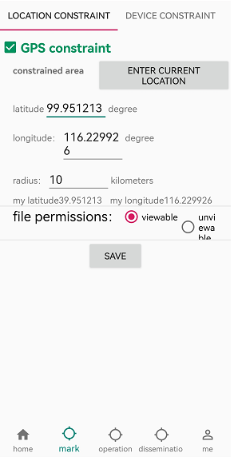

Fig.3-1 Setting GPS Constraints

After filling in, click the "Save Settings" button.

Then come to the "File List" interface, click the "Select Document" button to select the document, as shown in Fig.3-2.

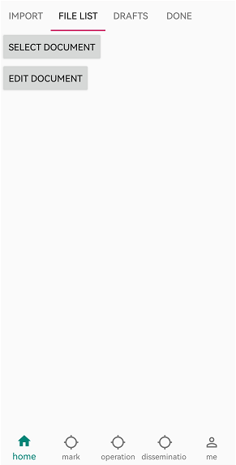

Fig.3-2 Begin to select documents

The interface for selecting a document is shown in Fig.3-3. Select the document whose file name is "d.ofd ", and the interface after opening the document is shown in Fig.3-4.

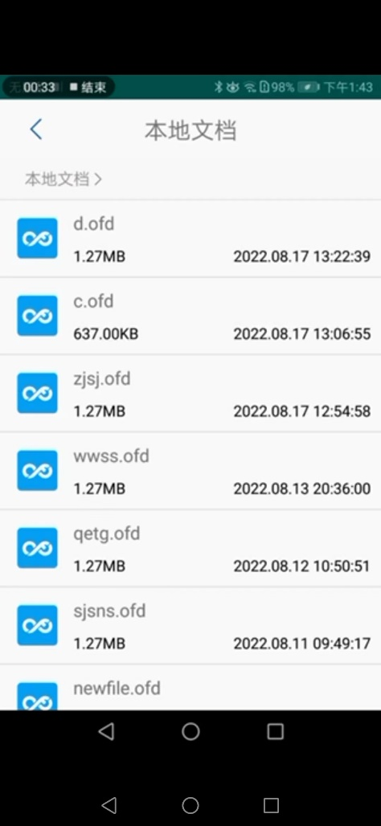

Fig.3 - 3 Select Documents

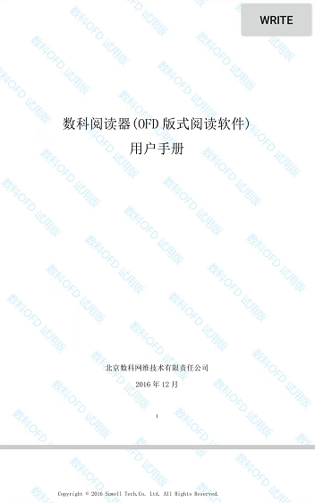

Fig.3-4 Open Document _

After opening the document, click the "Write Comment" button to write the GPS constraints we just set in the form of privacy control language. The writing result is shown in Fig.3-5.

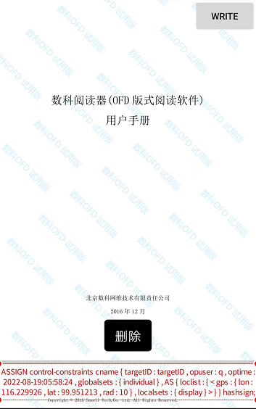

Fig.3-5 Write G PS Constraints _

Since we are within the range that the previously set file can be opened, select the document again, and the document can be opened normally, as shown in Fig.3-6.



Fig.3-6 Open the document normally

Return to the GPS constraint setting interface again and change the settings of the GPS constraint, as shown in Fig.3-7.

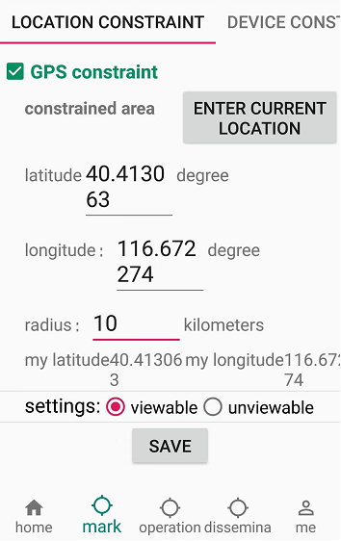

Fig.3-7 Setting the GPS Constraints

At this time, it is not within the set circular area, and the file cannot be opened. When the file is opened again, as shown in Fig.3-8, the file cannot be opened.

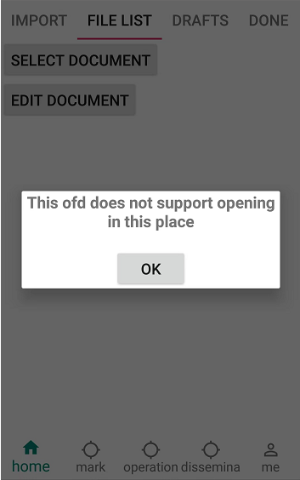

Fig.3-8 The file cannot be opened

**3.2 Device Constraints**

**3.2.1 Constraints by Device Type**

Constraints by device type refer to restricting which types of devices the ofd file can be opened by. There are two types of classification, one is mobile phone and the other is tablet. Users can click to select which device can be opened and displayed.

Figures 3-9 and 3-10, the currently selected options are "Mobile Phone", "Tablet", "Displayable" and "Fill in Current Device Machine Code" is clicked to fill in the machine code, if the reading device has this The machine code can view this ofd file on both mobile phones and tablets.

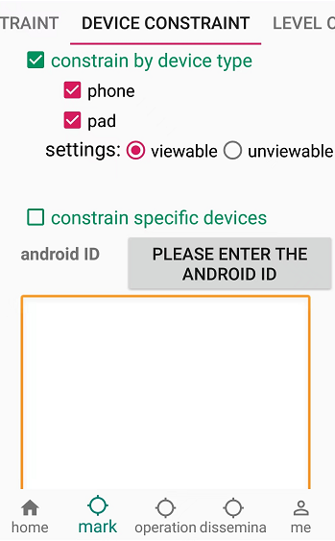

Fig.3-9 Setting Device Type Constraints

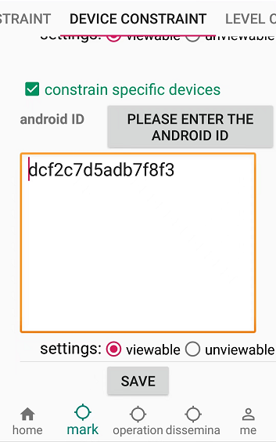

Fig.3-10 Fill in the machine code

After making your selections, click the "Save Settings" button

Then come to the "File List" interface, click the "Select Document" button to select the document, as shown in Fig.3-11.



Fig.3-11 Begin to select documents

The interface for selecting a document is shown in Fig.3-11. Select the document whose file name is "d.ofd ", and the interface after opening the document is shown in Fig.3-12.



Fig.3-12 Select document

After opening the document, click the "Write Comment" button to write the GPS constraints we just set in the form of privacy control language. The writing result is shown in Fig.3-13.

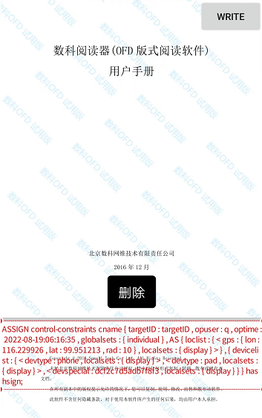

Fig.3-13 Write Device Constraint Statement

Since we have selected "mobile phone" and "tablet", this ofd can be displayed, and the current device type is mobile phone, so select the document again, and the document can be opened normally. As shown in Fig.3-14.

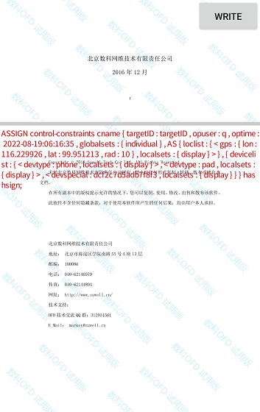

Fig.3-14 Open the file normally

Return to the device constraint interface again and change the settings, as shown in Fig.3-15

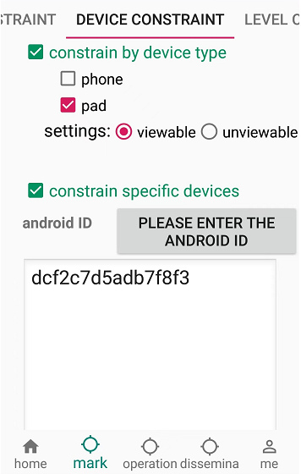

Fig.3-15 Change settings

At this time, since the current device is not a tablet, the file cannot be opened. When the file is opened again, as shown in Fig.3-16, it cannot be opened.

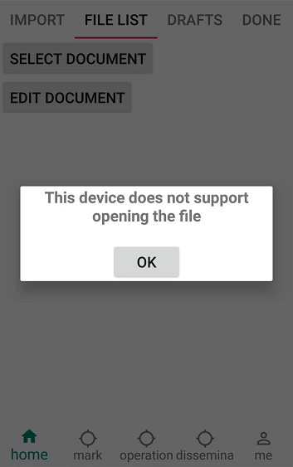

Fig.3-16 Unable to open file

After making your selections, click the "Save Settings" button

Then come to the "File List" interface, click the "Select Document" button to select the document, as shown in Fig.3-17.



Fig.3-17 Begin to select documents

The interface for selecting a document is shown in Fig.3-17. Select the document whose file name is "d.ofd", and the interface after opening the document is shown in Fig.3-18.



Fig.3-18 Select Document _

After opening the document, click the "Write Comment" button to write the GPS constraints we just set in the form of privacy control language. The writing result is shown in Fig.3-19.



Fig.3-19 Write Device Constraint Statement

Since we have selected "mobile phone" and "tablet", this ofd can be displayed, and the current device type is mobile phone, so select the document again, and the document can be opened normally. As shown in Fig.3-20.



Fig.3-20 Open the file normally

Return to the device constraint interface again and change the settings, as shown in Fig.3-21



Fig.3-21 Change settings

At this time, since the current device is not a tablet, the file cannot be opened. When the file is opened again, as shown in Fig.3-22, it cannot be opened.



Fig.3-22 Unable to open file

**3.2.2 Specifying Device Constraints**

Specifying device constraints refers to restricting which specific device the ofd file can be opened. The device machine code is actually the Android ID. The user fills in the machine code and chooses whether it can be displayed to achieve the function of whether a specific device can open the ofd file. . Users can click the "Fill in the current machine code" button to fill in the current device machine code with one click.

As shown in Fig.3-23 below, the user fills in the machine code and selects "displayable", then the device with this machine code can display this ofd file.

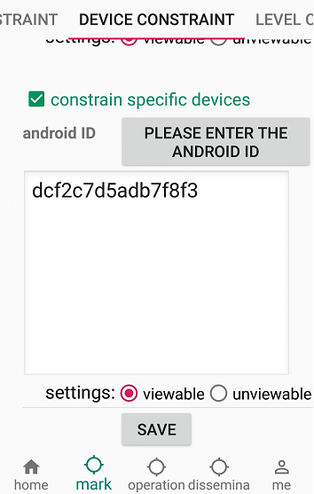

Fig.3-23 Setting specific device constraints

After making your selections, click the "Save Settings" button

Then come to the "File List" interface, click the "Select Document" button to select the document, as shown in Fig.3-24.



Fig.3-24 Begin to select documents

The interface for selecting a document is shown in Fig.3-25. Select the document whose file name is "d.ofd".



Fig.3-25 Select Document _

After opening the document, click the "Write Comment" button to write the device constraints we just set in the form of privacy control language. The writing result is shown in Fig.3-26.

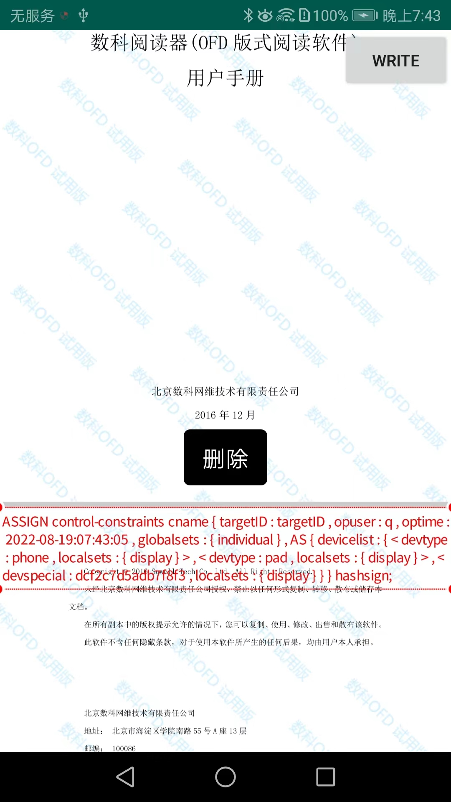

Fig.3-26 Write Device Constraint Statement

Since the machine code of our current device meets the requirements, and the selected "mobile phone" and "tablet" can be opened, select the document again, and the document can be opened normally. As shown in Fig.3-27.



Fig.3-27 Open the file normally

Return to the device constraint interface again and change the settings, as shown in Fig.3-28.

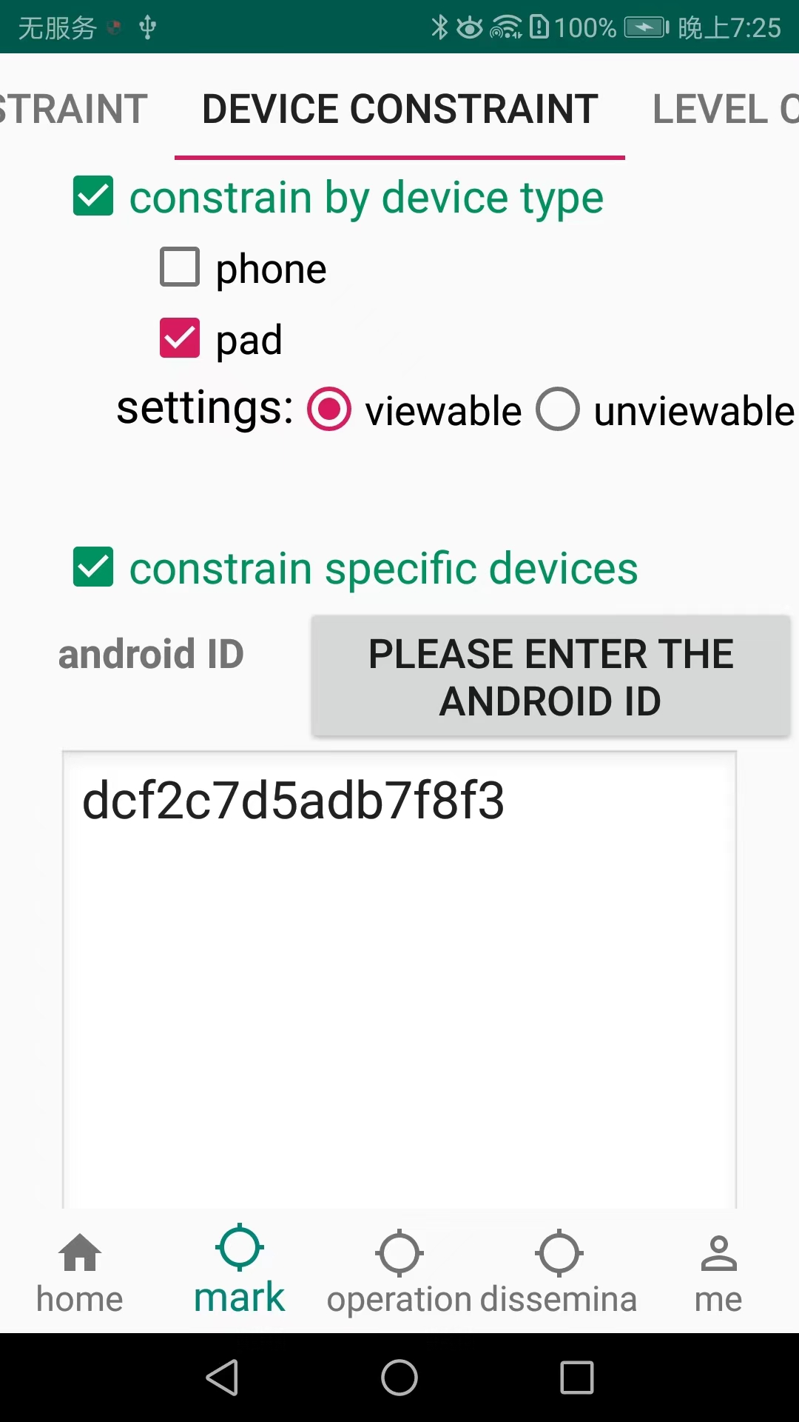

Fig.3-28 Change settings

At this time, although the machine code is correct, the current device is not a tablet, so the file cannot be opened. When opening the file again, as shown in Fig.3-29, it cannot be opened.

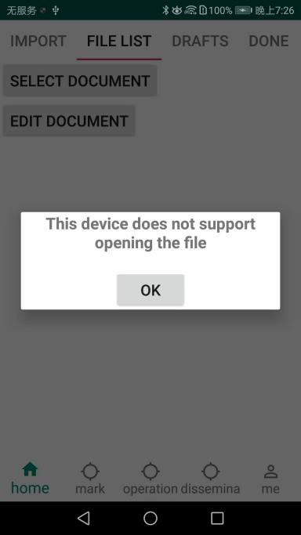

Fig.3-29 Unable to open file

**3.3 Hierarchical constraints**

In section 2.4, we can set the user permission level. The hierarchical constraint specifies the document level by writing comments, and compares the user level and the document level according to the user settings to determine whether the opening conditions are met. The setting interface is shown in Fig.3-30.

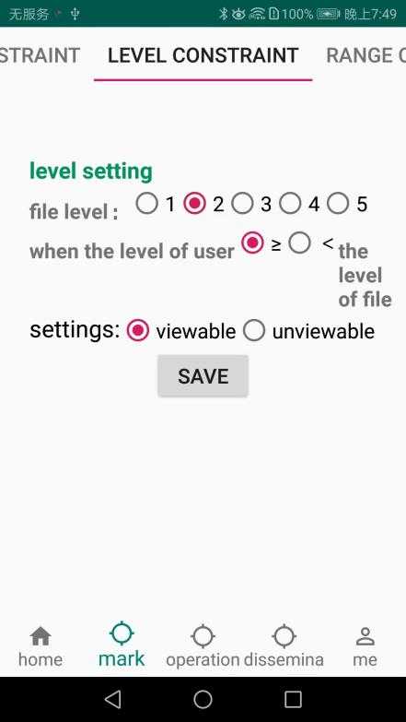

Fig.3-30 Setting Hierarchical Constraints

After filling in, click the "Save Settings" button.

Then come to the "File List" interface, click the "Select Document" button to select the document, as shown in Fig.3-31.

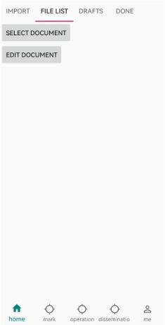

Fig.3-31 Begin to select documents

The interface for selecting a document is shown in Fig.3-32. Select the document whose file name is "d.ofd", and the interface after opening the document is shown in Fig.3-33.



Fig.3-32 Select document

After opening the document, click the "Write Comment" button to write the hierarchical constraints we just set in the form of privacy control language. The writing result is shown in Fig.3-34.

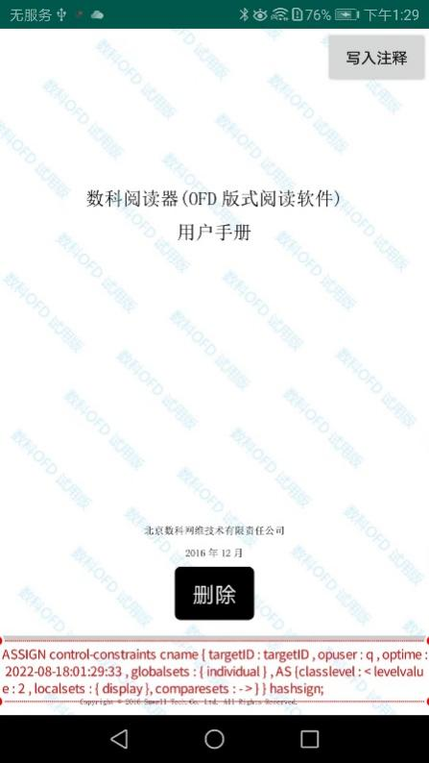

Fig.3-34 Write control language

Since the permission level we set before is 4, which is greater than the set document level 2, it is within the range that can be opened, so select the document again, and the document can be opened normally, as shown in Fig.3-35.

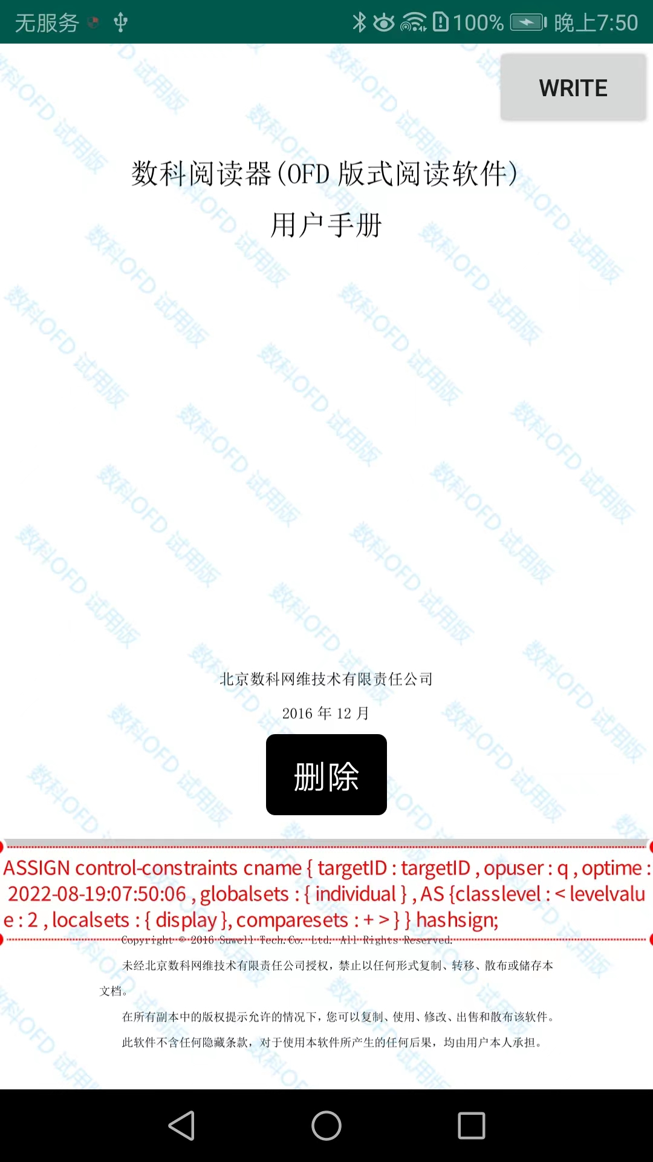

Fig.3-35 Open the document normally

Return to the hierarchy constraint setting interface again, and change the hierarchy constraint settings, as shown in Fig.3-36.

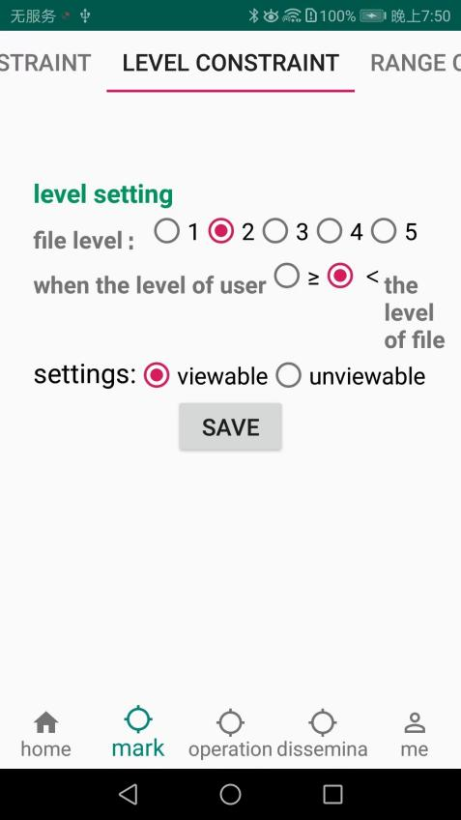

Fig.3-36 Setting Hierarchical Constraints

At this time, the user level 4 is still greater than the set document level 2, does not meet the constraints of less than or equal to 2, and cannot open the file. Open the file again, as shown in Fig.3-37, and the file cannot be opened.

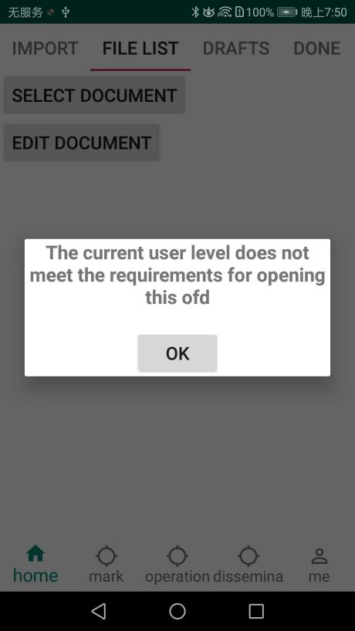

Fig.3-37 The file cannot be opened

**3.4 Control constraints**

**3.4.1 Scope of knowledge**

The range of knowledge in the control constraints refers to the current IP address. Intranet constraint means that the user can fill in the intranet IP to set whether the file can be displayed; external network constraint means that the user can fill in the extranet IP to set whether the file can be displayed.

As shown in Fig.3-38 below, the user fills in the external network IP and selects "displayable", then the device with this IP can display the ofd file.

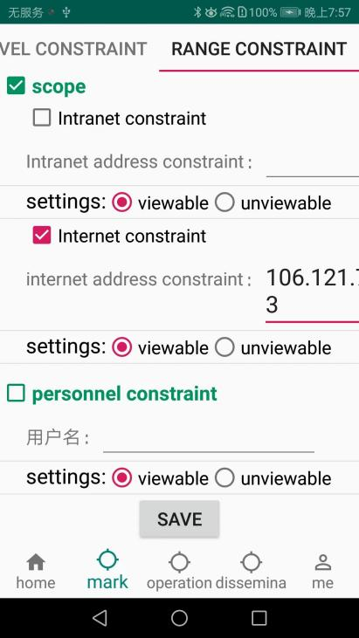

Fig.3-38 Setting the external network awareness scope constraint

After making your selections, click the "Save Settings" button

Then come to the "File List" interface, click the "Select Document" button to select the document, as shown in Fig.3-39.



Fig.3-39 Begin to select documents

The interface for selecting a document is shown in Fig.3-40. Select the document whose file name is "d.ofd", and the interface after opening the document is shown in Fig.3-41.



Fig.3-40 Select Document

After opening the document, click the "Write Comment" button to write the control constraints we just set in the form of privacy control language. The writing result is shown in Fig.3-42.

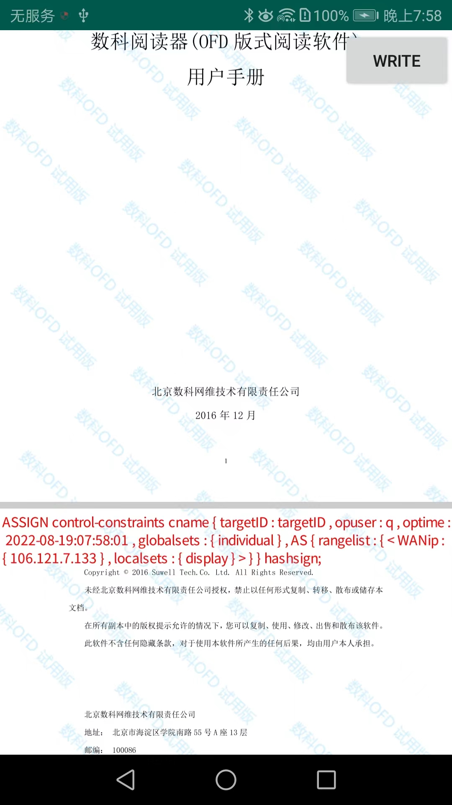

Fig.3 42 Write-Aware Scope Constraint Statement

Since our current IP meets the requirements to display this ofd, select the document again and the document can be opened normally. As shown in Fig.3-43.



Fig.3-43 Open the file normally

Return to the control constraint interface again and change the settings, as shown in Fig.3-44

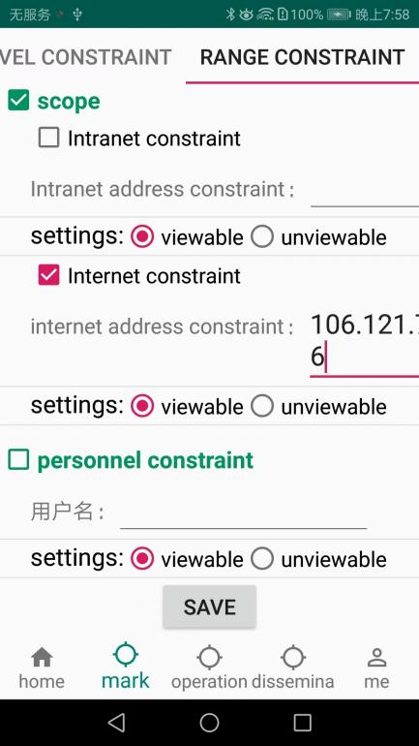

Fig.3-44 Modify the range of knowledge

At this time, because the current IP does not meet the requirements, the file cannot be opened, and the file cannot be opened again as shown in Fig.3-45.

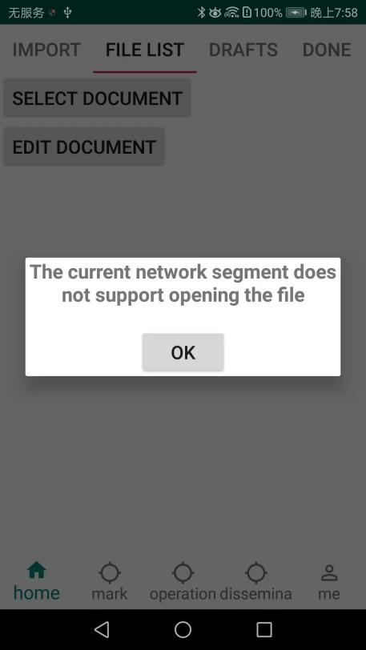

Fig.3-45 Unable to open file

**3.4.2 Constraints by personnel**

The per-person constraint in the management and control constraints means that the user can set the personnel who have the viewing permission for the ofd file.

As shown in Fig.3-46 below, the user fills in the user name "q" and selects "Displayable", then the user "q" can display the ofd file.

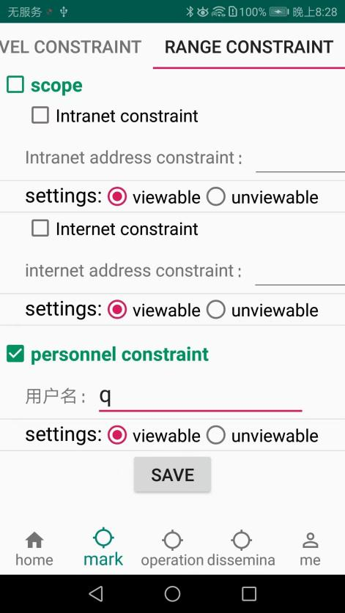

Fig.3-46 Setting personnel constraints

After making your selections, click the "Save Settings" button

Then come to the "File List" interface, click the "Select Document" button to select the document, as shown in Fig.3-47.

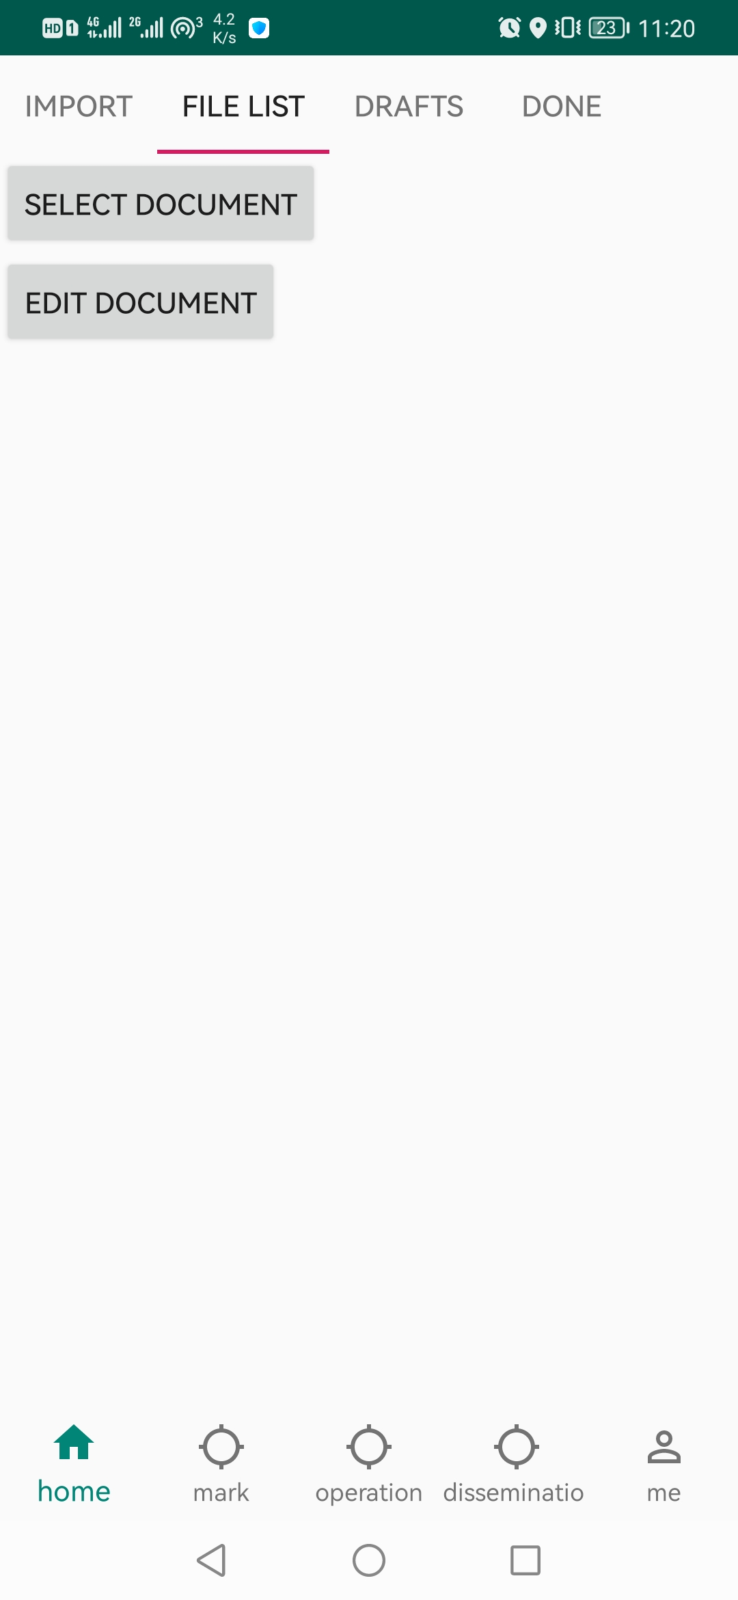

Fig.3-47 Begin to select documents

The interface for selecting a document is shown in Fig.3-48. Select the document whose file name is "d.ofd", and the interface after opening the document is shown in Fig.3-49.

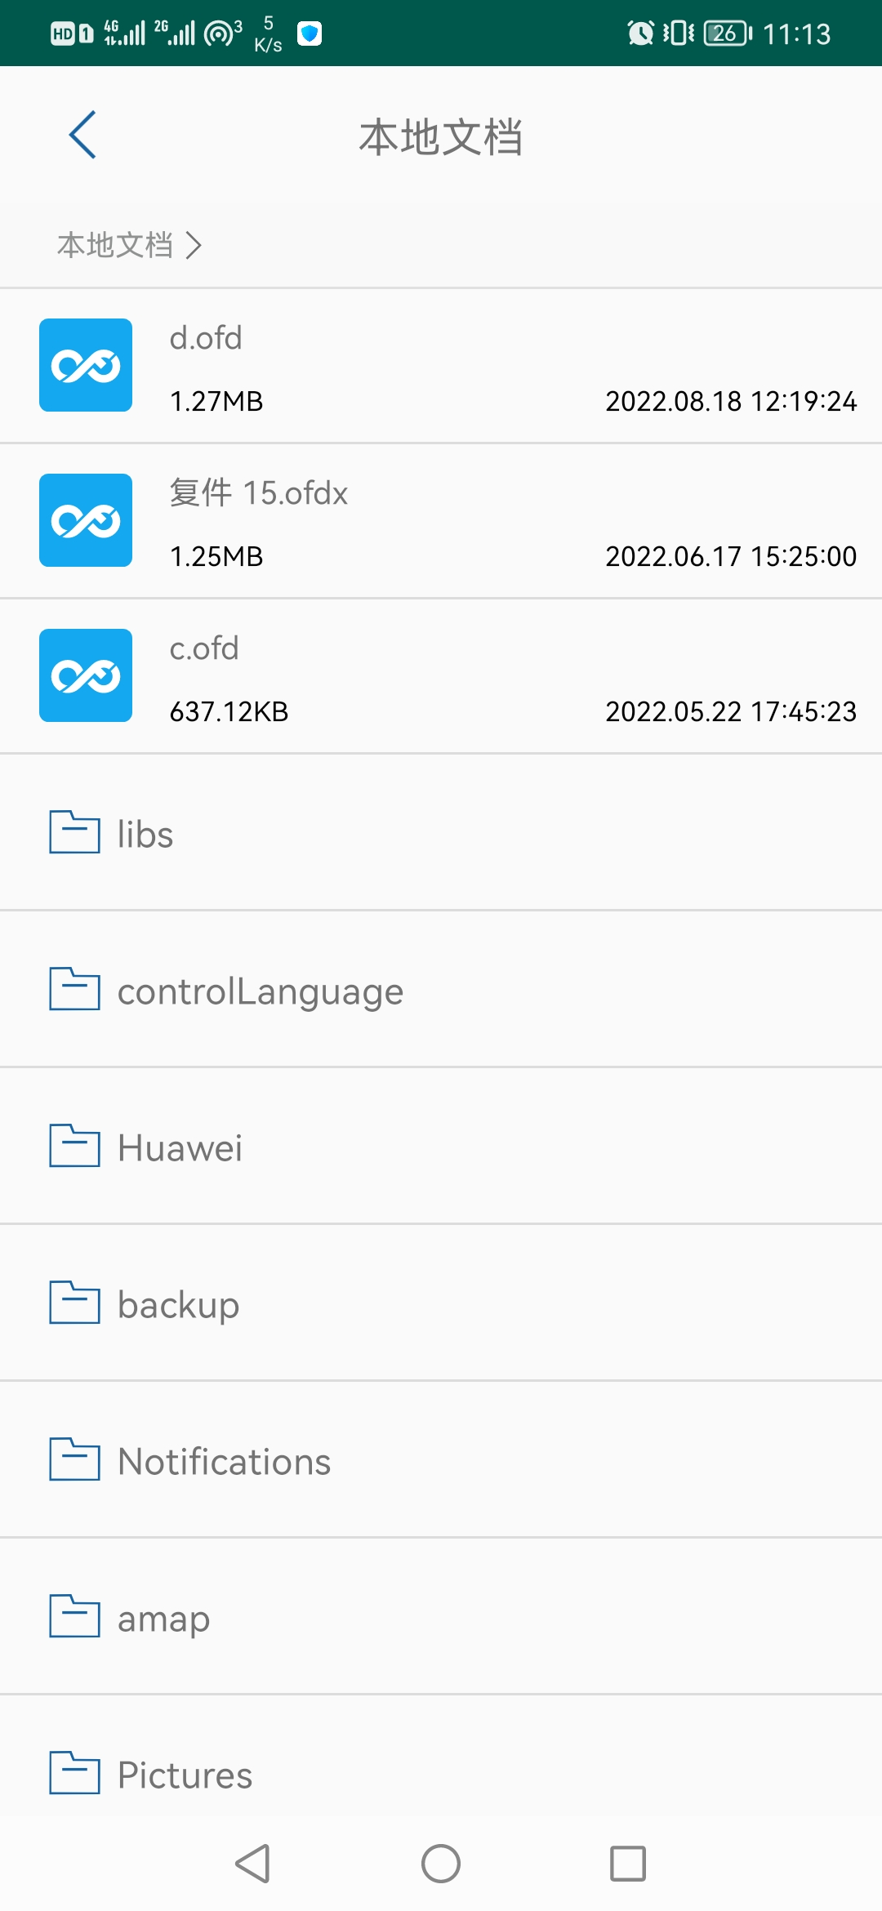

Fig.3-48 Select Document _

After opening the document, click the "Write Comment" button to write the personal constraints we just set in the form of privacy control language. The writing result is shown in Fig.3-50.

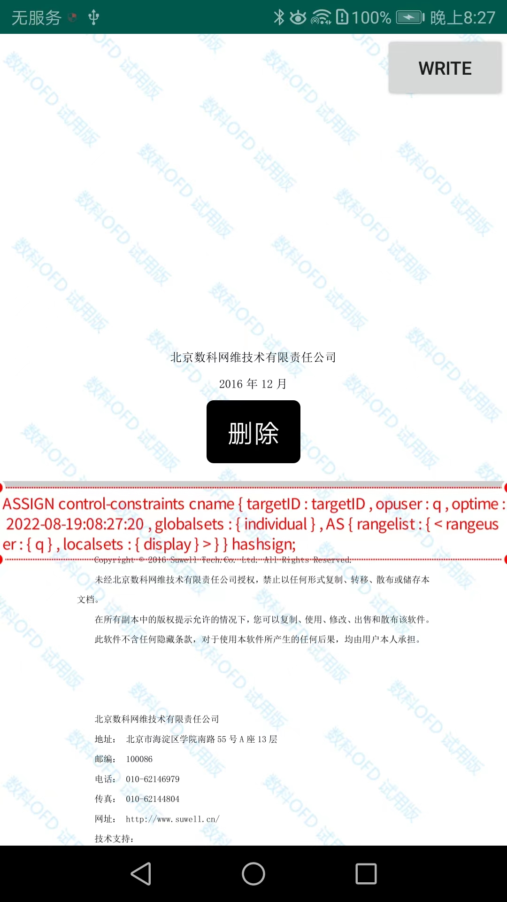

Fig.3-50 Write Personnel Constraint Statement

Since we are currently logged in as a user, the user name is "q", and this ofd can be displayed if it meets the requirements, so select the document again, and the document can be opened normally. As shown in Fig.3-51

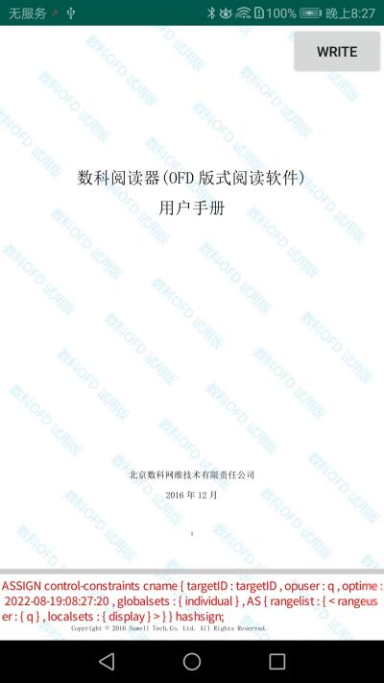

Fig.3-51 Open the file normally

Return to the control constraint interface again and change the settings, as shown in Fig.3-52

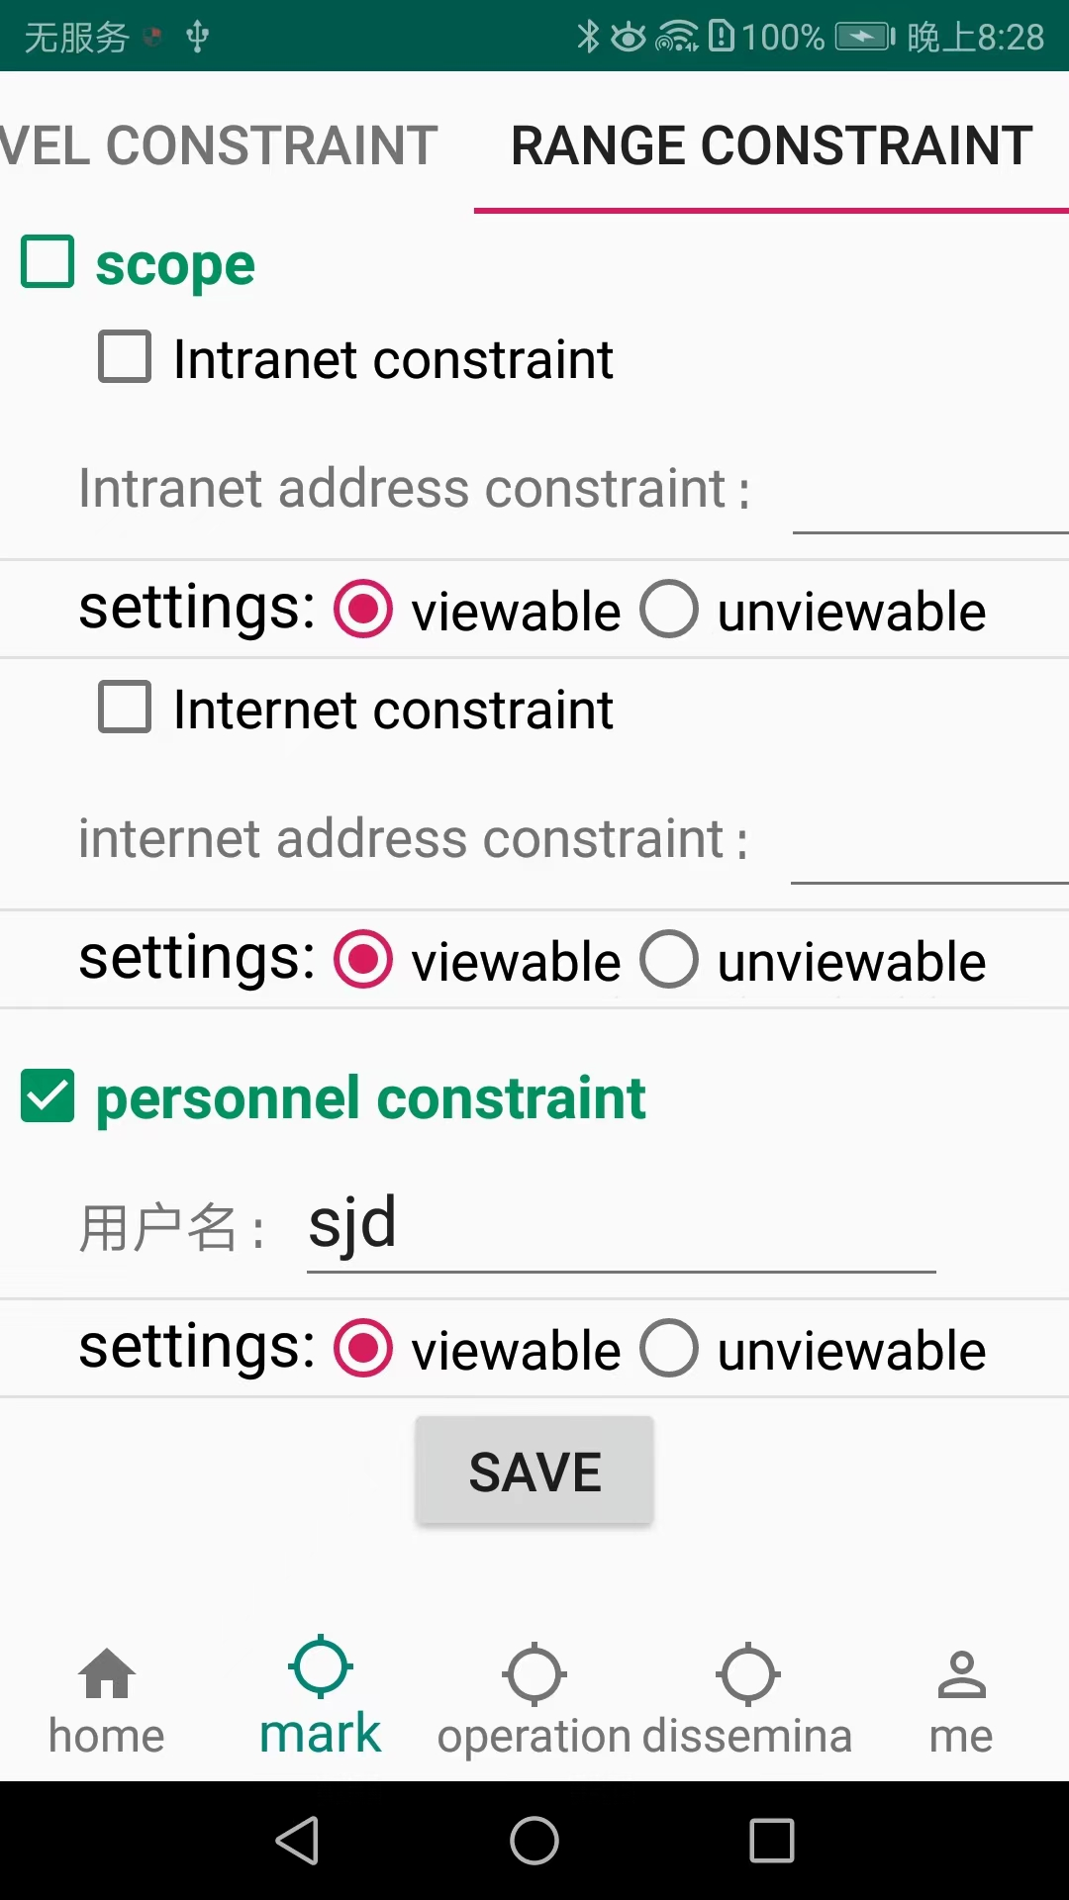

Fig.3-52 Modifying the User Constraint User Name

At this time, since the user name of the currently logged-in user is not "fhvh" and does not meet the requirements, the file cannot be opened, and the file cannot be opened again, as shown in Fig.3-53.

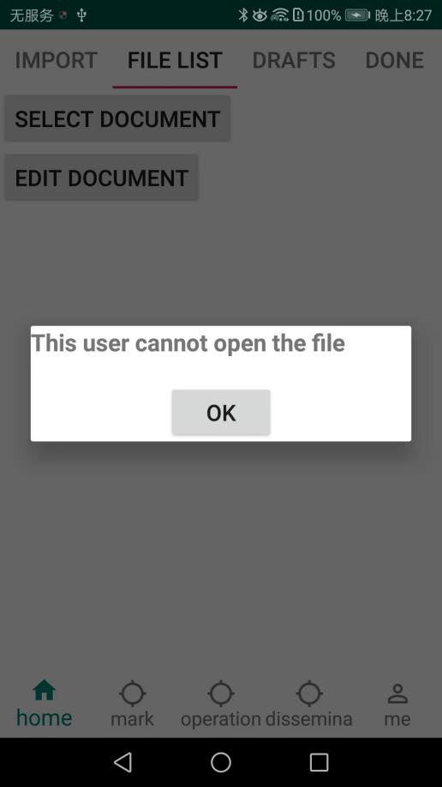

Fig.3-53 Unable to open file

**4. Operation**

**4.1 Desensitization constraints**

**4.1.1 Pages**

The desensitization page function means that when desensitizing a certain page of this ofd file, all the content in the page will not be displayed. separated by ";".

As shown in Fig.4-1 below, if the user fills in "1", the first page of the document will be desensitized.

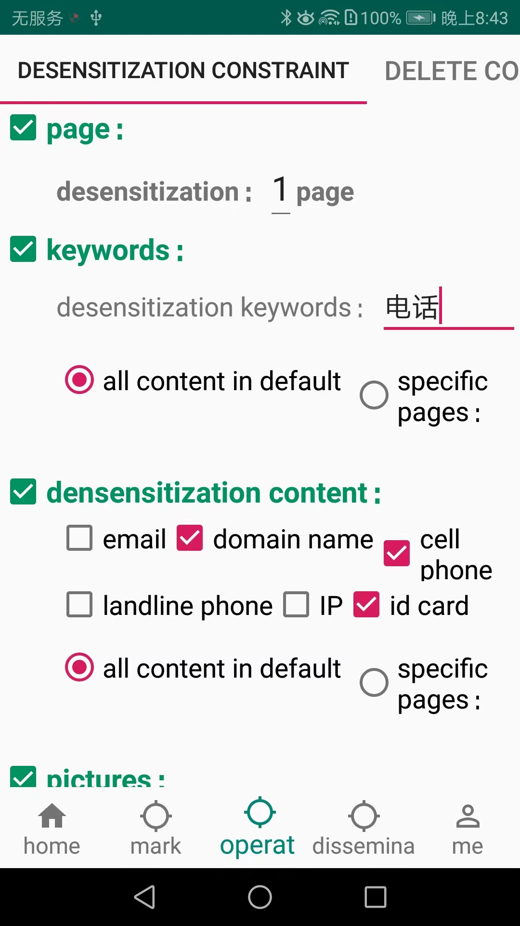

Fig.4-1 Setting desensitization page

After selecting, set the file name after desensitization, and click the "Save Settings" button.

Then come to the "File List" interface, click the "Select Document" button to select the document, as shown in Fig.4-2.

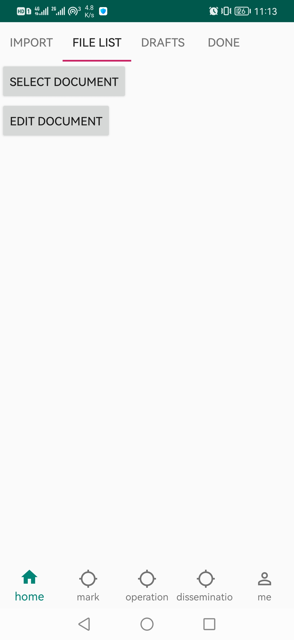

Fig.4-2 Begin to select documents

The interface for selecting a document is shown in Fig.4-3. Select the document with the file name " d.ofd ", and the interface after opening the document is shown in Fig.4-4.



Fig.4-3 Select document

After opening the document, click the "Write Comment" button to write the desensitization requirements we just set in the form of privacy control language. The writing result is shown in Fig.4-5.

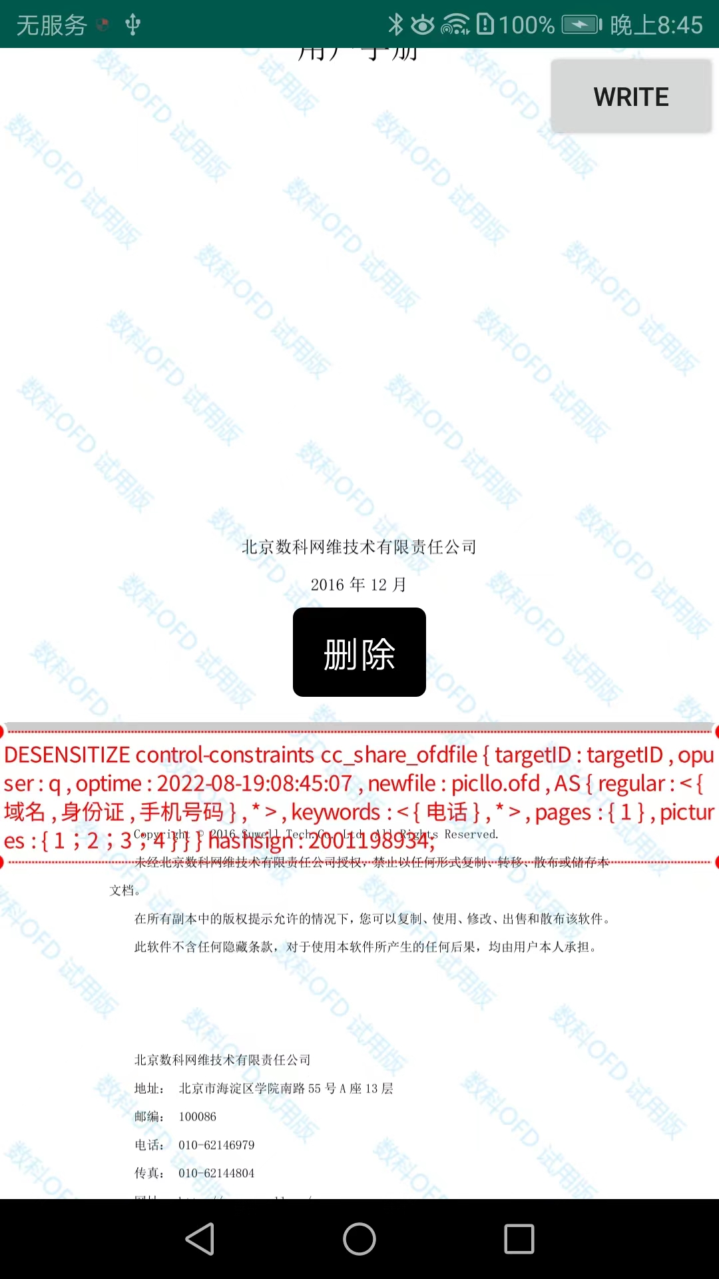

Fig.4-5 Write desensitization request statement

Click "Select Document" again, and select d.ofd, the page jumps to the waiting interface, as shown in Fig.4-6.

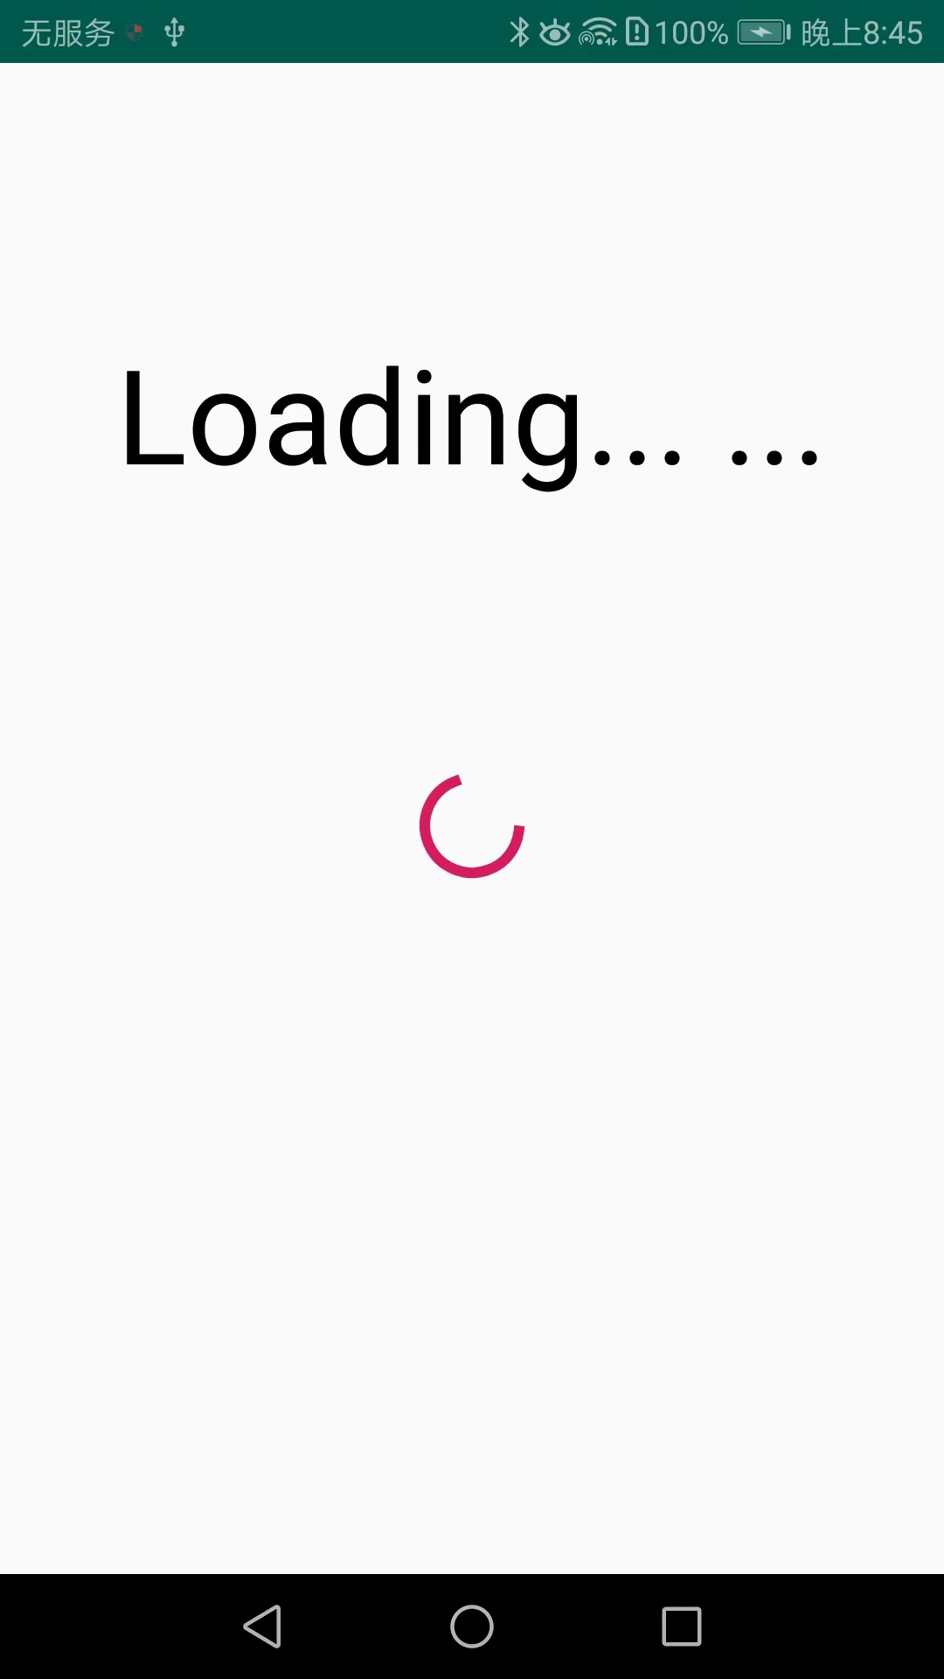

Fig.4-6 Waiting interface

the new desensitization file is generated, a new prompt box pops up to indicate that the desensitization has been completed, and a new button "jump to the generated OFD file" appears. As shown in Fig.4-7.

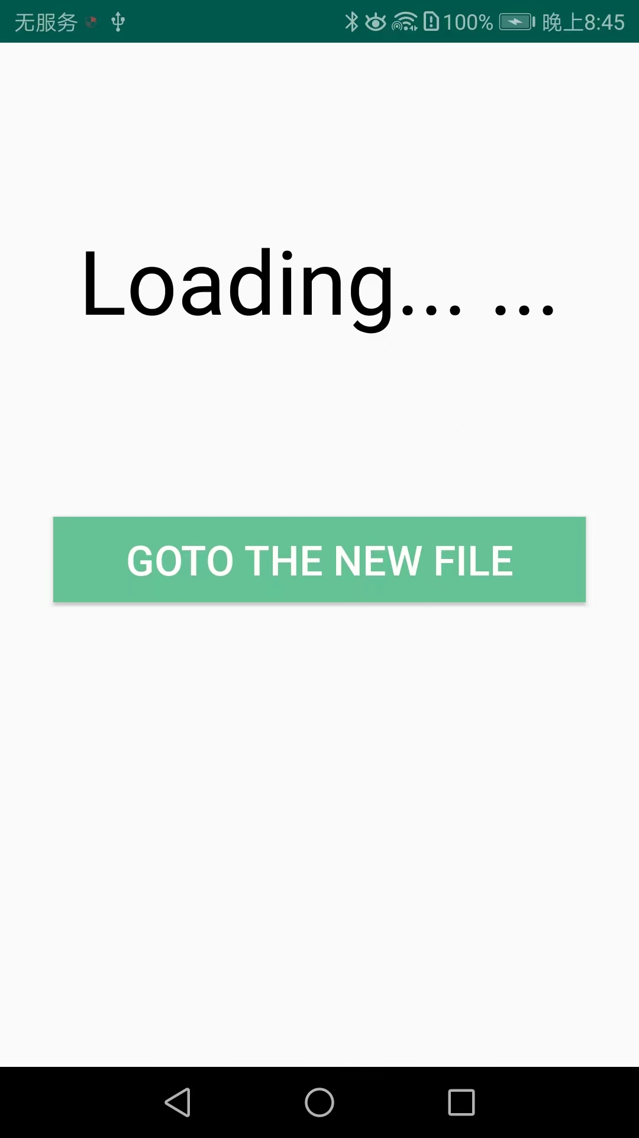

Fig.4-7 Desensitization completion prompt

Fig.4-8, click the new "Jump to the newly generated OFD file" button and automatically jump to the newly generated OFD file, and page 1 is successfully desensitized and blank content is displayed.

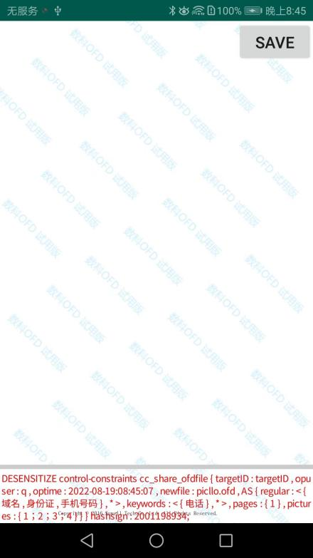

Fig.4-8 Successful desensitization page

**4.1.2 Keywords**

The keyword desensitization function refers to desensitizing certain pages of this ofd file or sentences containing keywords in the entire ofd file, and the desensitized sentences will not be displayed. Fill in the pages you want to desensitize in "Page", and separate multiple pages with ";", or select the default option to desensitize the entire ofd file; in "Desensitization Keywords: Fill in the keywords you want to desensitize in the column, and separate multiple keywords with ";".

As shown in Fig.4-9 below, if the user fills in the desensitization keyword "telephone" and selects "default full text", all pages of the document will be desensitized, and sentences containing "telephone" will be desensitized and not displayed.



Fig.4-9 Setting keyword desensitization

After making your selections, click the "Save Settings" button.

Then come to the "File List" interface, click the "Select Document" button to select the document, as shown in Fig.4-10.



Fig.4-10 Begin to select documents

The interface for selecting a document is shown in Fig.4-11 . Select the document with the file name "d.ofd ", and the interface after opening the document is shown in Fig.4-12.



Fig.4-10 Selecting a document

After opening the document, click the "Write Comment" button to write the desensitization requirements we just set in the form of privacy control language. The writing result is shown in Fig.4-12.



Fig.4-12 Write desensitization request statement

Click "Select Document" again, and select d.ofd, the page jumps to the waiting interface, as shown in Fig.4-13.

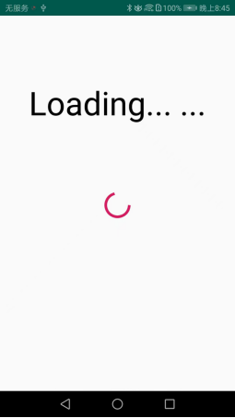

Fig.4-13 Waiting interface

the new desensitization file is generated, a new prompt box pops up to indicate that the desensitization has been completed, and a new button "jump to the generated OFD file" appears. As shown in Fig.4-14



Fig.4-14 Desensitization complete prompt

Fig.4-15 , after clicking the new "Jump to the newly generated OFD file " button, it will automatically jump to the newly generated OFD file. The sentence containing the word "telephone" is successfully desensitized, and the display blank content.

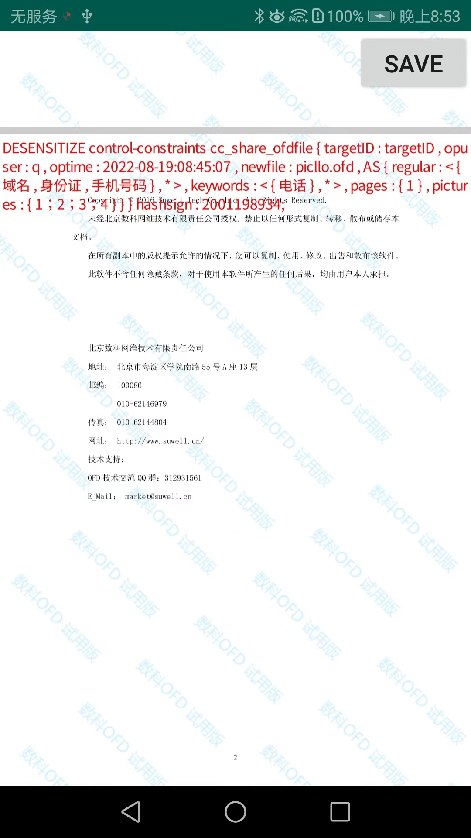

Fig.4-15 Successful desensitization page

**4.1.3 Content**

The desensitization content function refers to desensitizing certain pages of this ofd file or sentences with specific content in the entire ofd file, and the desensitized sentences will not be displayed. The principle is based on regular expressions. Desensitization Page: Section Fill in the pages you want to desensitize in "Page", and separate multiple pages with ";", or select the default option to desensitize the entire ofd file; then select specific content options, such as "mailbox", "domain name", etc.

As shown in Fig.4-16 below, if the user selects "Phone Number" and "ID Card", and the range is "Default Full Text", within the full text range, sentences related to "Phone Number" or "ID Card" will be desensitized and not displayed.

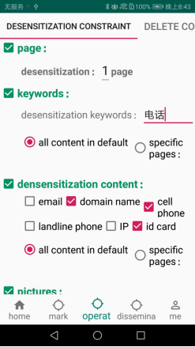

Fig.4-16 Setting desensitization requirements

After making your selections, click the "Save Settings" button

Then come to the "File List" interface, click the "Select Document" button to select the document, as shown in Fig.4-17.

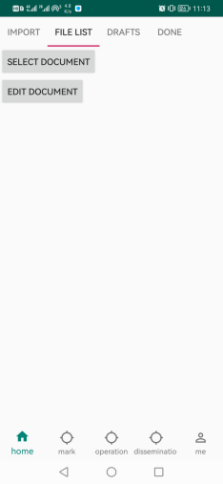

Fig.4-17 Begin to select documents

The interface for selecting a document is shown in Fig.4-18. Select the document with the file name "d.ofd", and the interface after opening the document is shown in Fig.4-19.



Fig.4-18 Select document

After opening the document, click the "Write Comment" button to write the desensitization requirements we just set in the form of privacy control language. The writing result is shown in Fig.4-20.

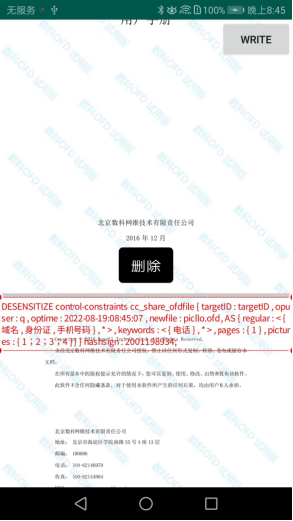

Fig.4-20 Write desensitization request statement

Click "Select Document" again, and select d.ofd , the page jumps to the waiting interface, as shown in Fig.4-21.



Fig.4-21 Waiting interface

the new desensitization file is generated, a new prompt box pops up to indicate that the desensitization has been completed, and a new button "jump to the generated OFD file" appears. As shown in Fig.4-22

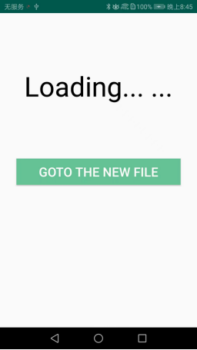

Fig.4 -22 Desensitization completion prompt

Fig.4-23 , after clicking the new "Jump to the newly generated OFD file " button, it will automatically jump to the newly generated OFD file, and the sentences related to the phone number and ID card are successfully desensitized, and the display is blank. content.



Fig.4-23 Successfully desensitized content

**4.1.4 Pictures**

The picture desensitization function refers to desensitizing some pictures in this ofd file, and dividing multiple pictures with ";", for example, "5;6" means desensitizing the 5th and 6th pictures, and the pictures are sorted according to their The order of appearance in the ofd file is sorted.

As shown in Fig.4-24 below, if the user fills in " 1 ; 2; 3; 4" in the desensitization picture column, the 1st , 2nd, 3rd, and 4th pictures of the document will not be displayed.



Fig.4-24 Setting desensitization picture requirements

After making your selections, click the "Save Settings" button.

Then come to the "File List" interface, click the "Select Document" button to select the document, as shown in Fig.4-25.



Fig.4-25 Begin to select documents

The interface for selecting a document is shown in Fig.4-26. Select the document with the file name "d.ofd", and the interface after opening the document is shown in Fig.4-27.



Fig.4-26 Select document

After opening the document, click the "Write Comment" button to write the desensitization requirements we just set in the form of privacy control language. The writing result is shown in Fig.4-28.



Fig.4-28 Write desensitization request statement

Click "Select Document" again, and select d.ofd, the page jumps to the waiting interface, as shown in Fig.4-29.



Fig.4-29 Waiting interface

the new desensitization file is generated, a new prompt box pops up to indicate that the desensitization has been completed, and a new button "jump to the generated OFD file" appears. As shown in Fig.4-30



Fig.4-30 Desensitization completion prompt

Fig.4-31 , click the new "Jump to the newly generated OFD file " button and automatically jump to the newly generated OFD file. The original picture is replaced by our "test" picture, which is successfully removed sensitive.

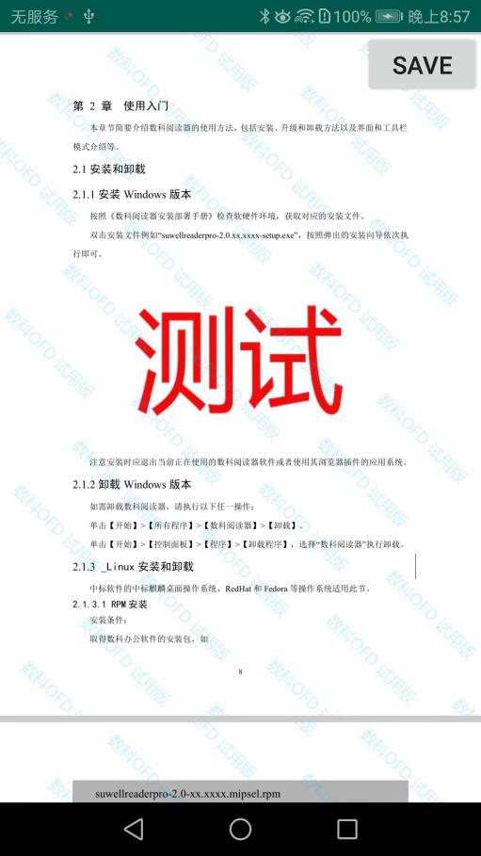

Fig.4 -31 Desensitization picture is successful

**4.2 Deleting constraints**

**4.2.1 Automatically delete by countdown**

Automatic deletion by countdown means that after the user opens the file for a certain period of time, the system automatically deletes the file, that is, restricts the user's browsing and saving time for the file. Fig.4-32 shows the setting page of automatic deletion by countdown. In Fig.4-32, the set deletion countdown is 5 seconds, that is, after the user opens the corresponding document and browses for 5 seconds, the system will automatically delete the document. After setting the countdown, click the "Save Settings" button to save the settings.

After setting the deletion countdown, go to the "File List" interface and click the "Select Document" button to select a document, as shown in Fig.4-33.

The interface for selecting a document is shown in Fig.4-34. Select the document whose file name is "Delete Countdown.ofd", which is a document created to verify the automatic deletion function according to the countdown.

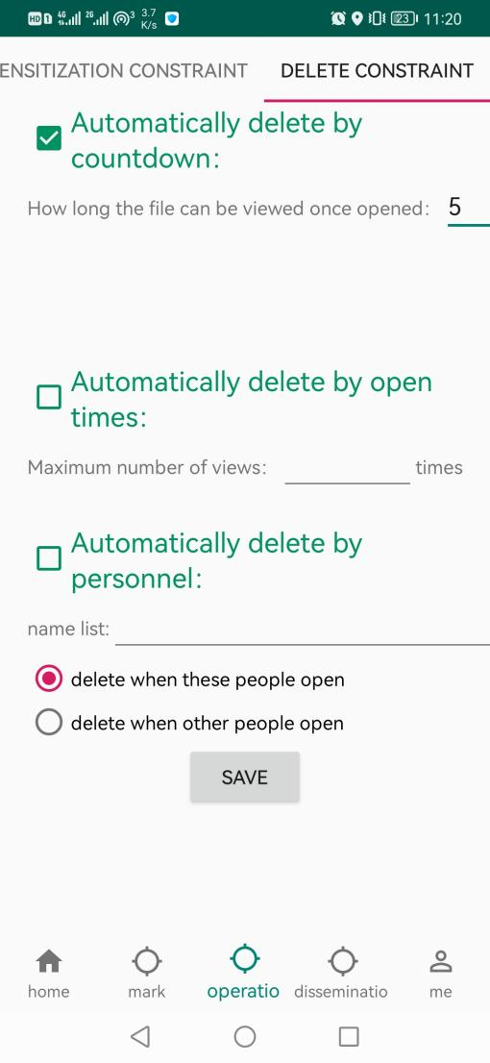

Fig.4-32 Setting the countdown to delete



Fig.4-33 Begin to select documents

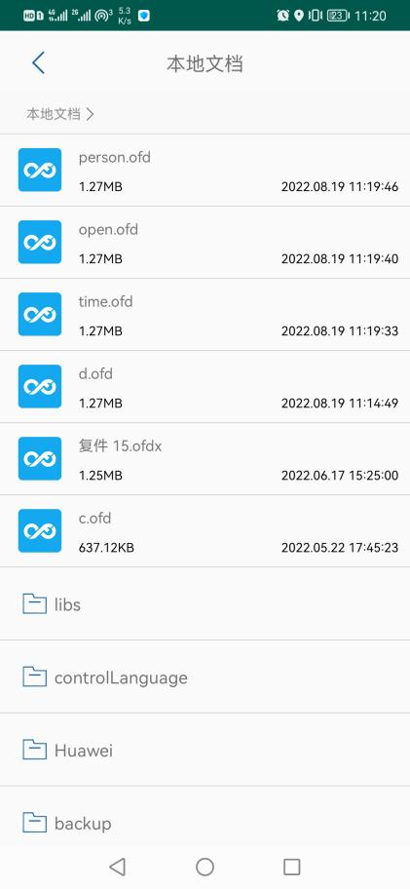

Fig.4-34 Select Document _

Fig.4-34, after selecting the document, open the document and view the content in the document, as shown in Fig.4-35.

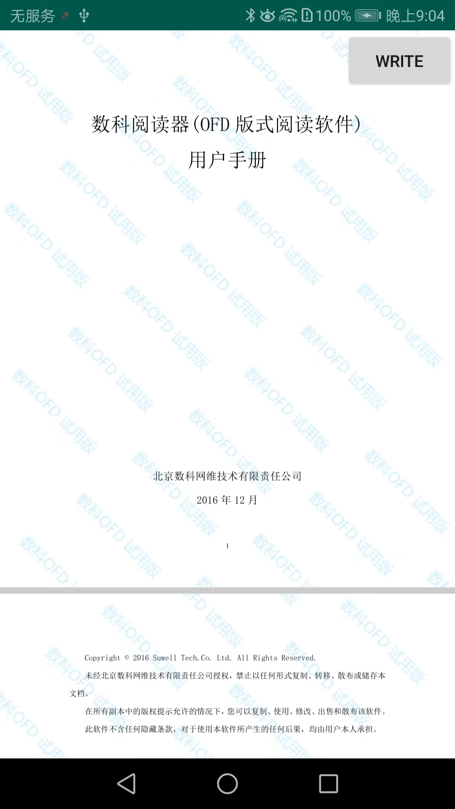

Fig.4-35 Open Document _

After opening the document, click the "Write Comment" button, and write the countdown deletion we just set in the form of privacy control language. The writing result is shown in Fig.4-36.

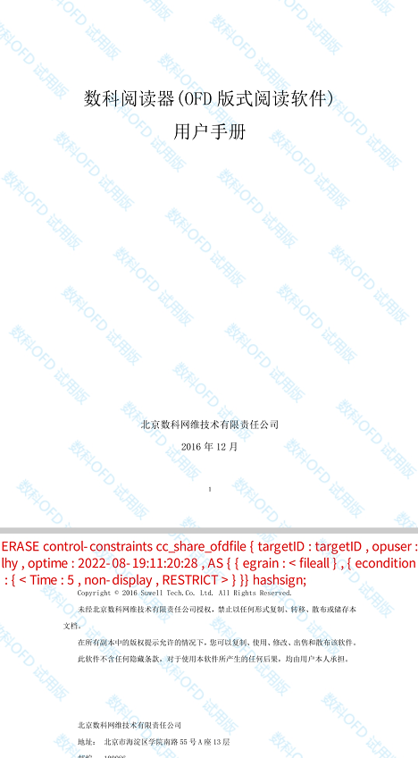

Fig.4 - 36 Write Control Language

After writing the control language, the control settings for this document succeeded. After exiting, reopen the document, and you can see that the time when the document can be opened will be displayed, as shown in Fig.4-37.



Fig.4-37 Open the document again

After 5 seconds of opening the document, the document will be automatically deleted, and it will return to the document selection interface in Figure 4-33. Click the "Select Document" button again. In the displayed document list, there is no document named "Delete Countdown.ofd", which has been deleted, as shown in Figure 4-38.

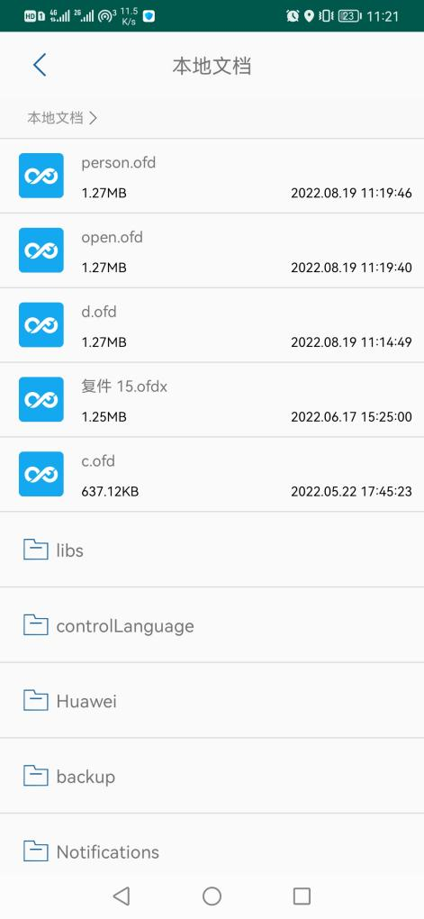

Fig.4-38 Select Document List

**4.2.2 Automatically delete according to the number of openings**

According to the number of openings means that the system automatically deletes the file after the user opens the file for a certain number of times, that is, limits the number of times the user opens the file.

Fig.4-39 shows the setting page of automatic deletion according to the number of openings. In Fig.4-39 , the set number of times the file can be opened is 2 , that is, after the user opens the corresponding document twice, the system will automatically delete the document when it is opened again. After setting the opening times, click the "Save Settings" button to save the settings.

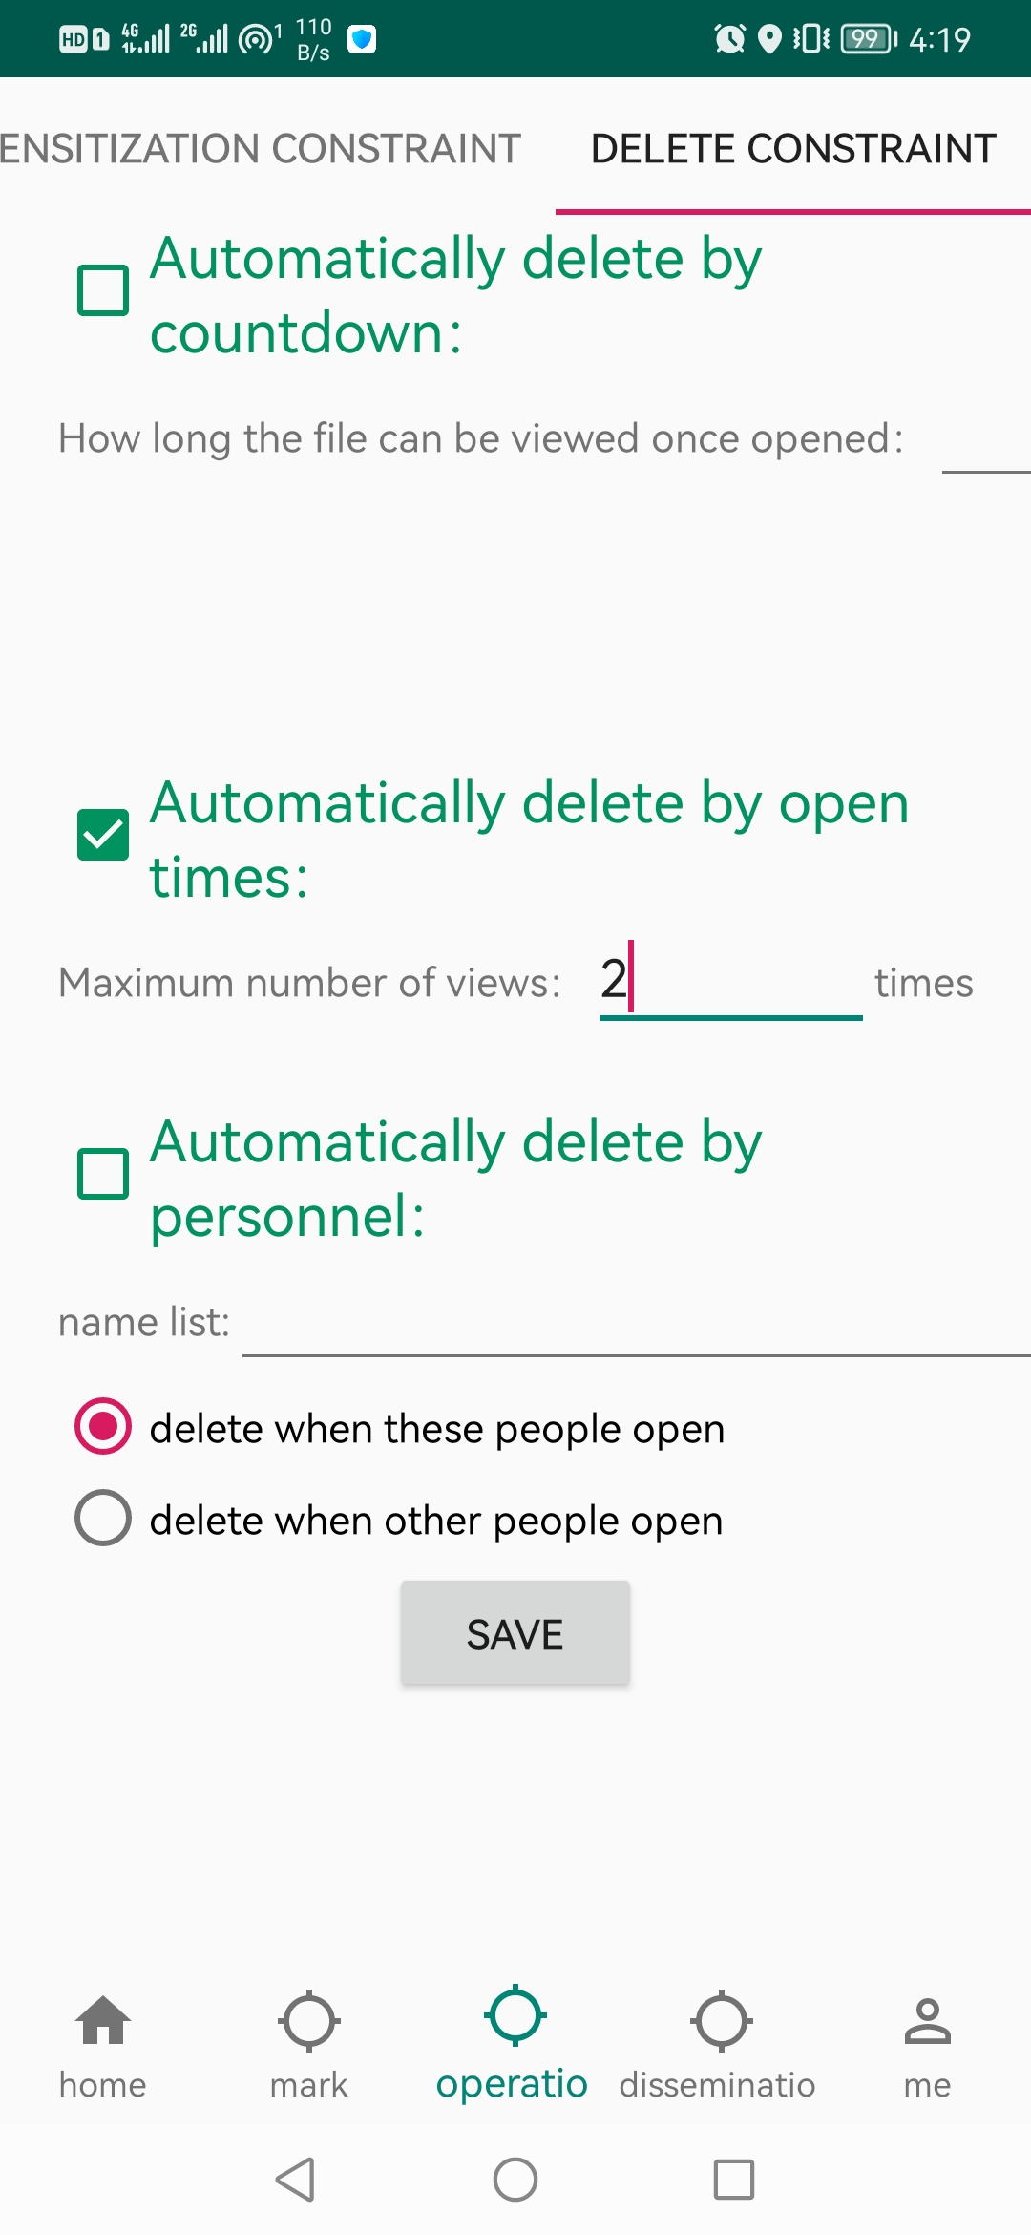

Fig.4 - 39 Set the number of openings

After setting the number of openings, go to the "File List" interface and click the "Select Document" button to select a document, as shown in Fig.4-40.

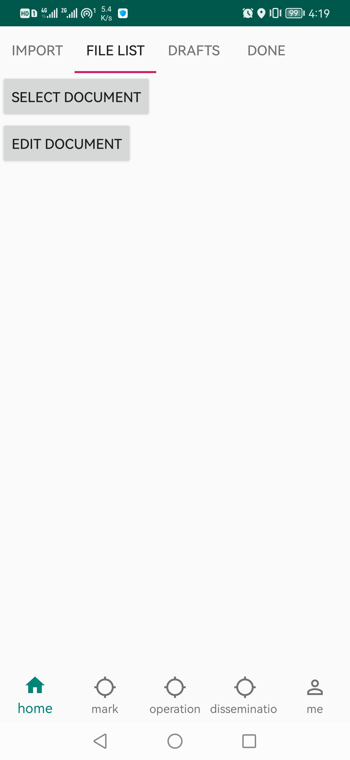

Fig.4-40 Begin to select documents

The interface for selecting a document is shown in Fig.4-41. Select the document with the file name of "open times.ofd ", which is a document created to verify the automatic deletion function according to the countdown.

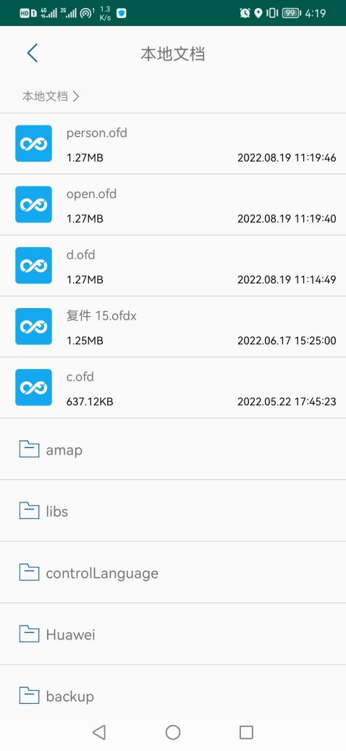

Fig.4-41 Select Document

As Fig.4-41, after selecting the document, open the document and view the content in the document, as shown in Fig.4-42 .



Fig.4-42 Open Document _

By opening times we just set in the form of privacy control language. The writing result is shown in Fig.4-43.

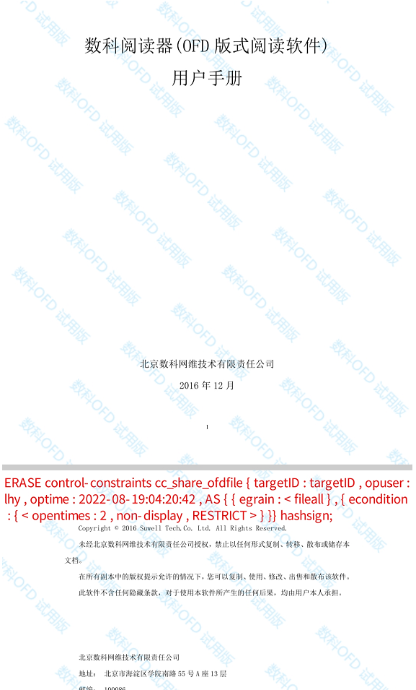

Fig.4-43 Write Control Language

After writing the control language, the control settings for this document succeeded. After exiting, reopen the document. When opening the document for the first time, it can be opened, as shown in Fig.4-44.



Fig.4-44 Opening the document for the first time

Next, when opening the document for the second time, it can be opened, as shown in Fig.4-45.



Fig.4-45 Open the document for the second time

When the document is opened for the third time, it will display that the document has been deleted, as shown in Fig.4-46.

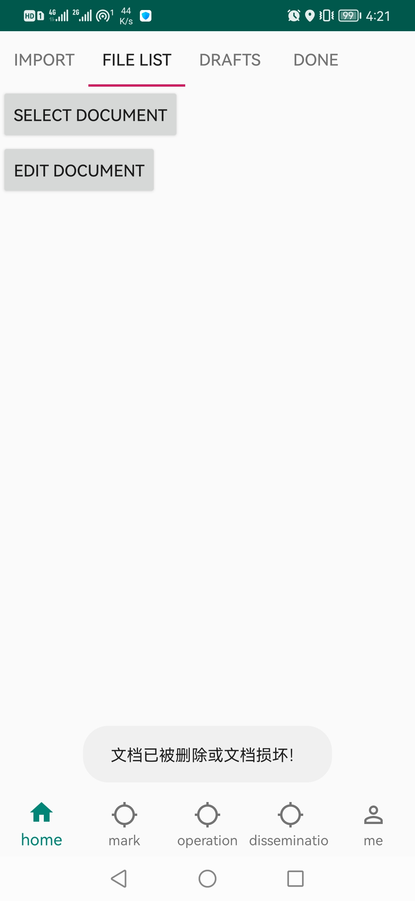

Fig.4 - 46 Documents have been deleted

Go to the document selection interface in Fig.4-40, and click the "Select Document" button again. In the displayed document list, there is no document named "Open Times. ofd", which has been deleted, as shown in Fig.4-47.

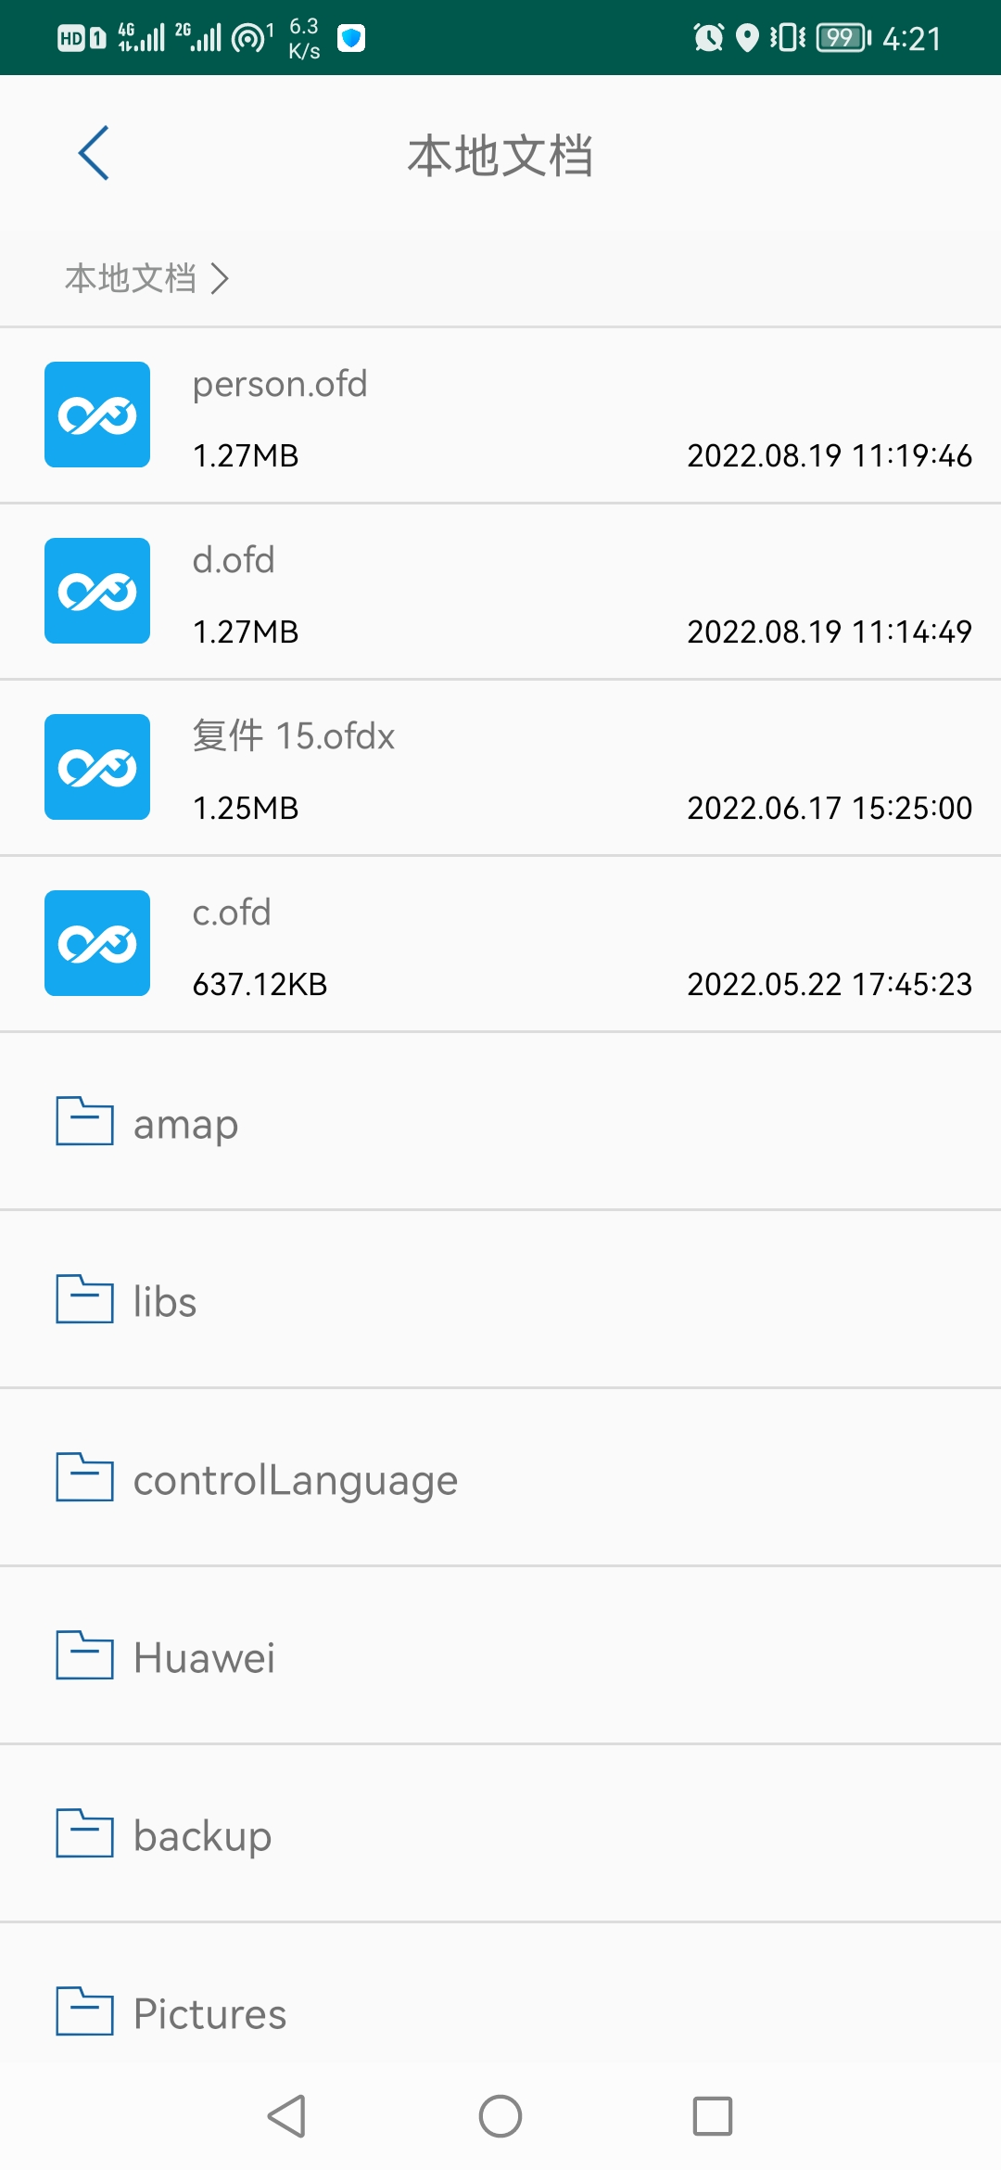

Fig.4-47 Select Document List

**4.2.3 Automatically delete by viewing personnel**

Automatic deletion by viewing person means that when a document is viewed by a designated person, the document cannot be opened, and the system automatically deletes the document.

Fig.4-48 shows the setting interface of automatic deletion by viewing personnel. In Fig.4-48 , the set personnel list is " lhy ", and the set type is "delete when the above personnel open the file", that is, when the user named " lhy " opens the corresponding document, the system will directly The corresponding document is deleted. After setting the viewing personnel, click the "Save Settings" button to save the settings.

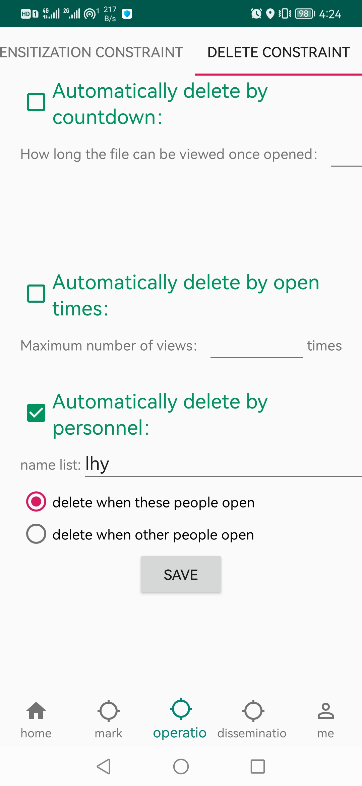

Fig.4-48 Setting Viewer _

After setting the viewing personnel, go to the "File List" interface and click the "Select Document" button to select a document, as shown in Fig.4-49.

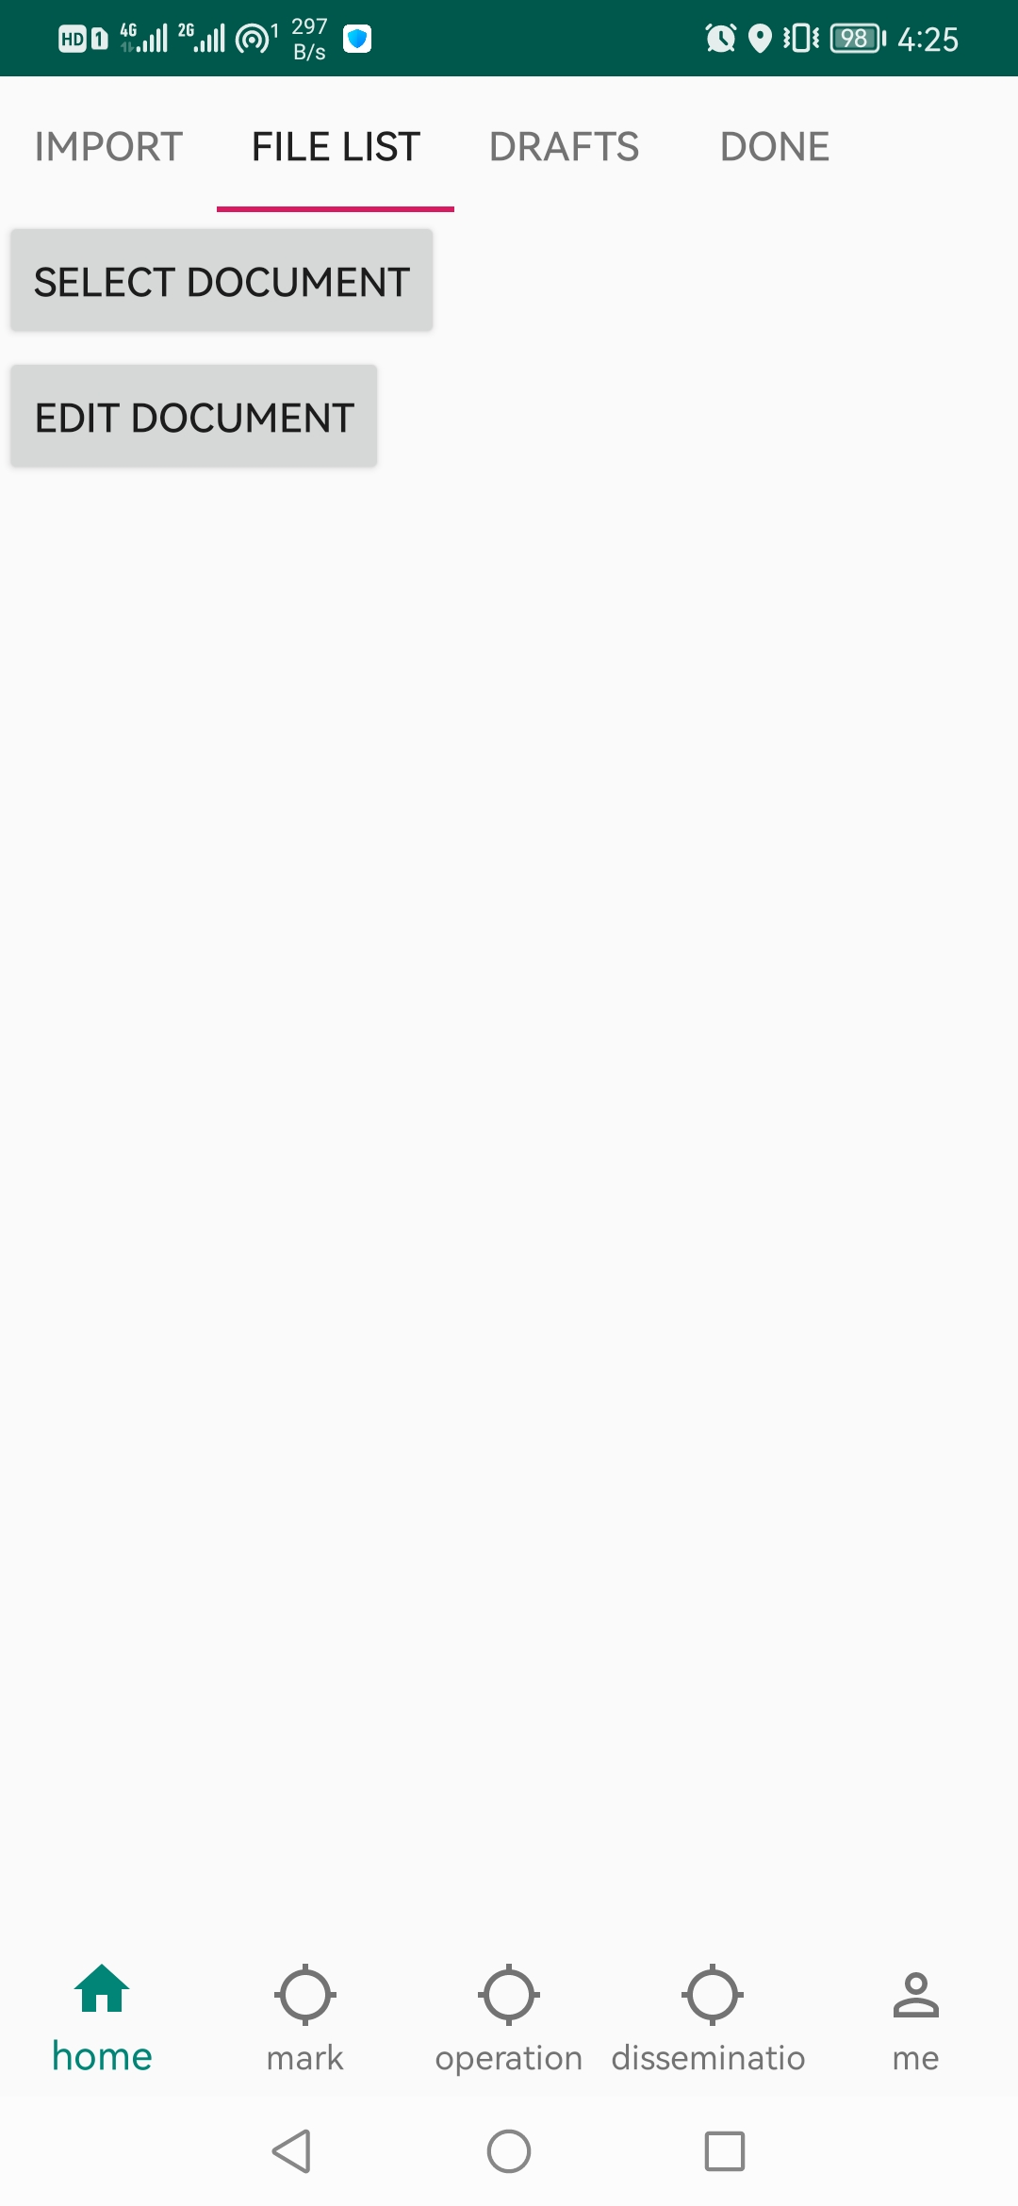

Fig.4-49 Begin to select documents

The interface for selecting a document is shown in Fig.4-50. Select the document whose file name is "Viewer. ofd ", which is created to verify the automatic deletion function by viewing personnel.

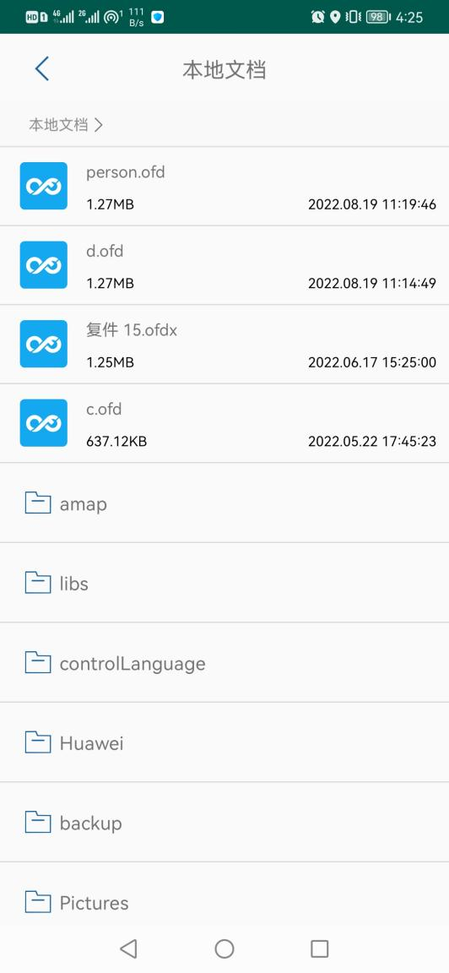

Fig.4-50 Select Document _

Fig.4-50, after selecting the document, open the document and view the content in the document, as shown in Fig.4-51.

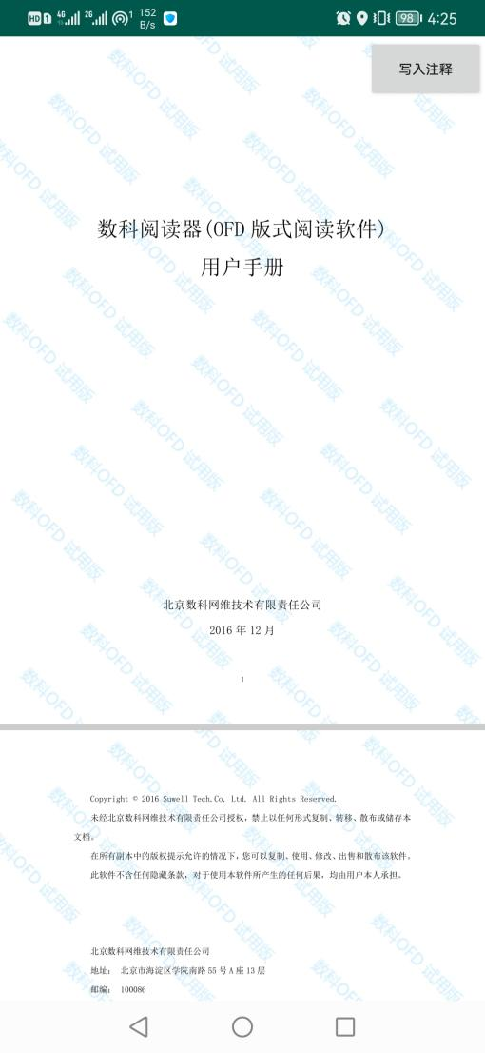

Fig.4-51 Open Document _

After opening the document, click the "Write Comment" button, and write the "Delete by Viewer" that we just set in the form of privacy control language. The writing result is shown in Fig.4-52.

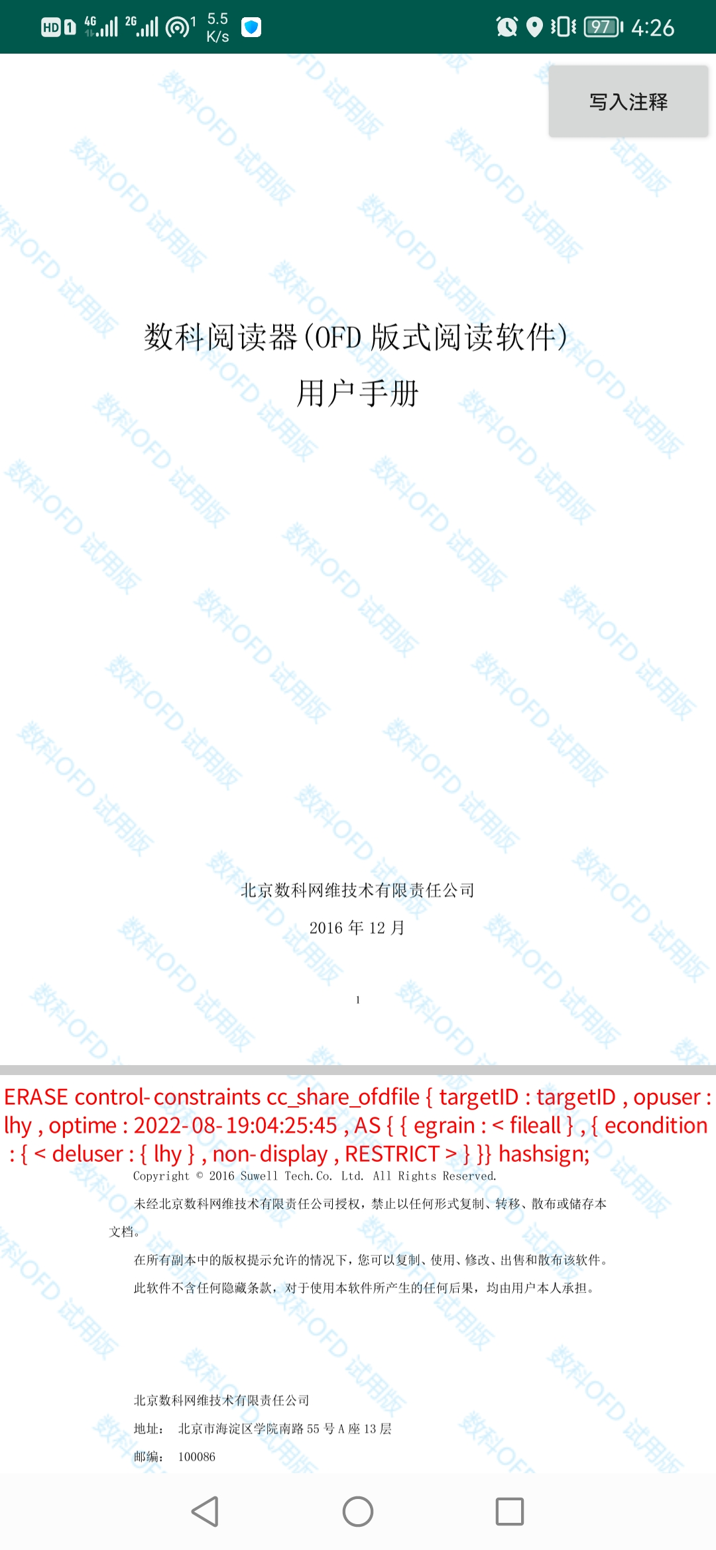

Fig.4-52 Write Control Language

After writing the control language, the control settings for this document succeeded.

When opening the document, use the current user name " q ", as shown in Fig.4-53 . Since it is not a person in the personnel list, the user can open the file normally, as shown in Fig.4-54.

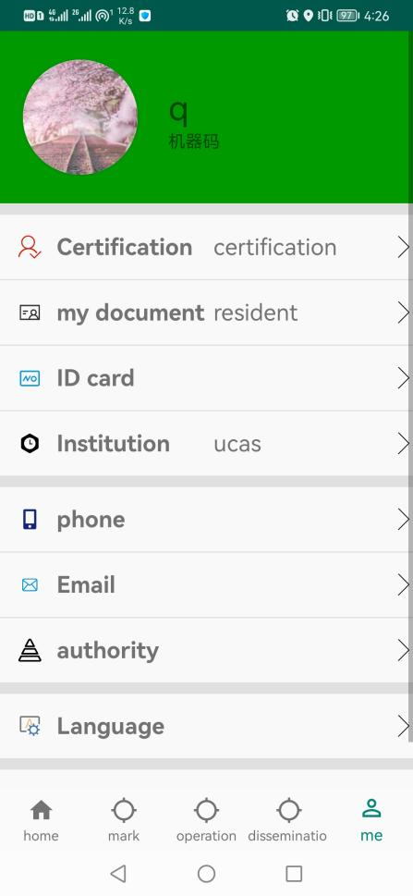

Fig. 4-53 User q



Fig.4-54 Open the file normally

Next, switch users and open the file with the user whose user name is " lhy ". The user information is shown in Fig.4-55. In Fig.4-50, after selecting the document "Viewer.ofd" in the document selection interface, it is displayed that the document failed to open and the file was deleted, as shown in Fig.4-56.

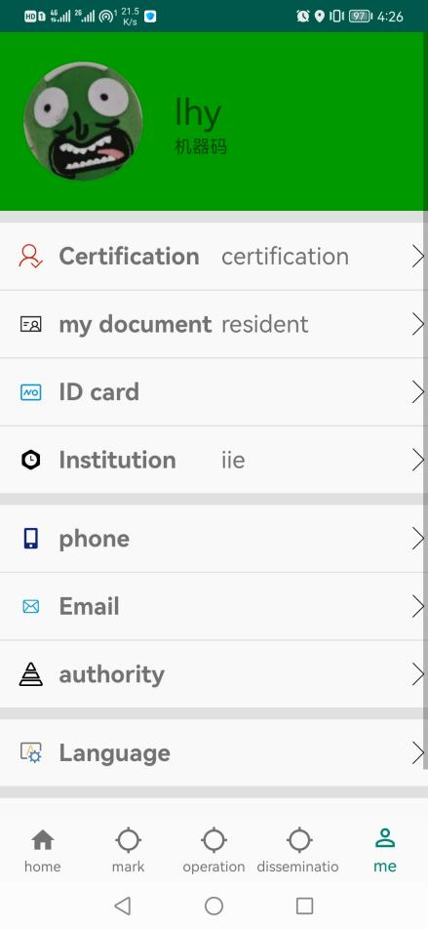

Fig. 4-55 user lhy

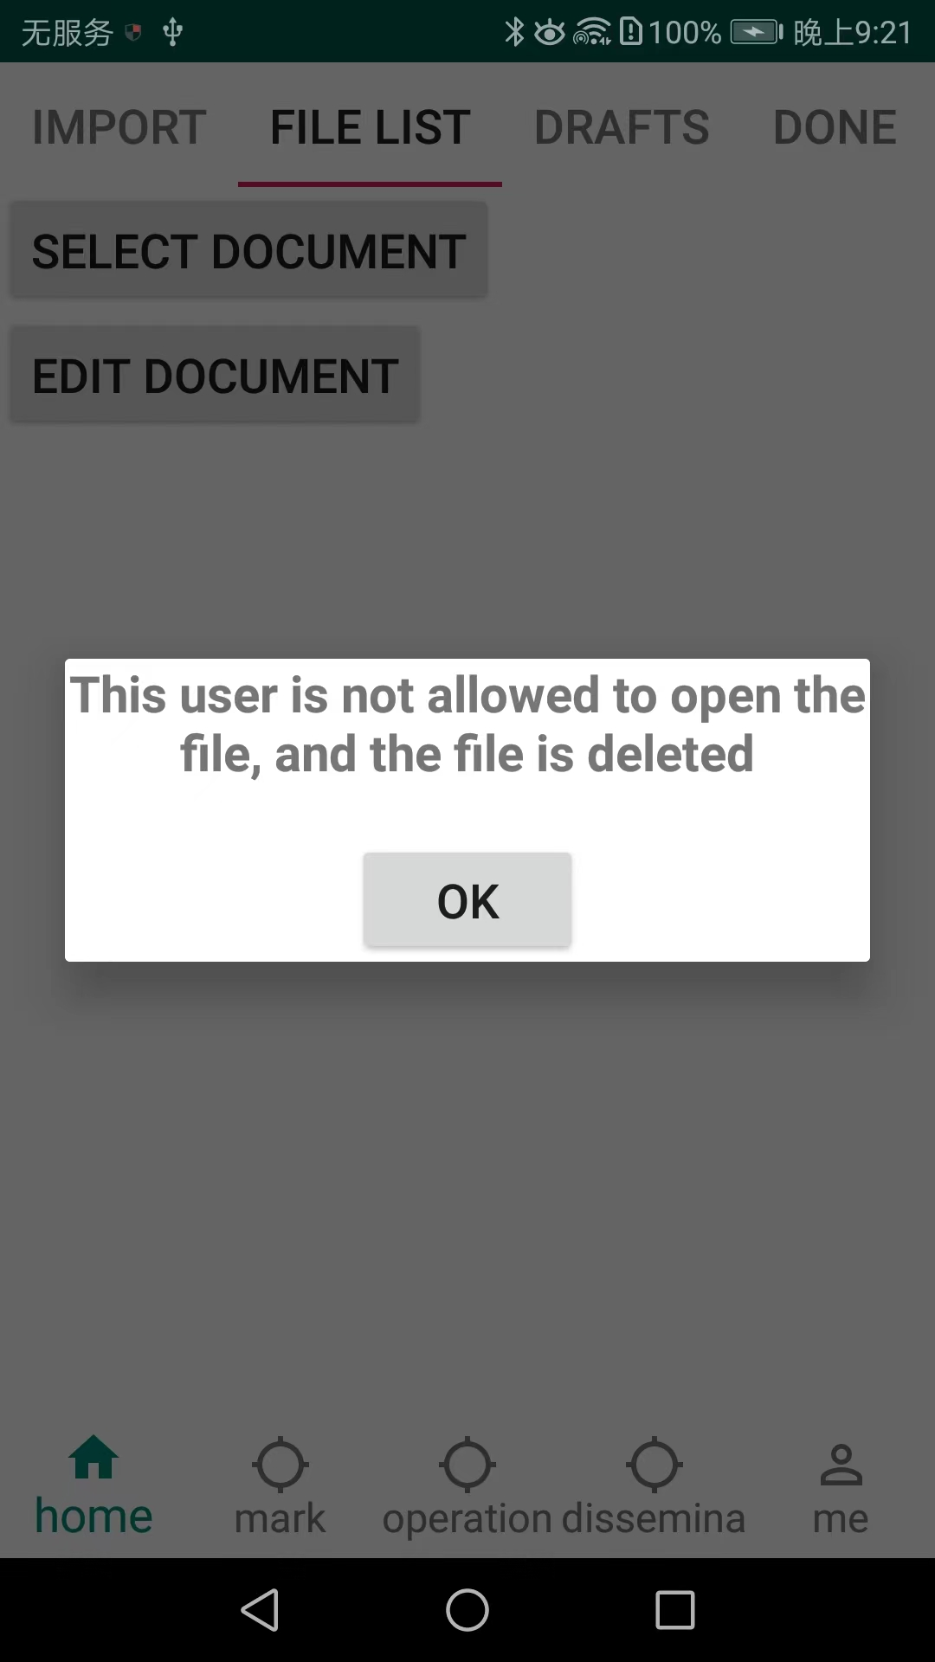

Fig. 4-56 File open failed

to the document selection interface in Fig.4-49 , click the "Select Document" button again, there is no document named " Viewer.ofd " in the displayed document list, and the document has been deleted, as shown in Fig.4-57 Show.

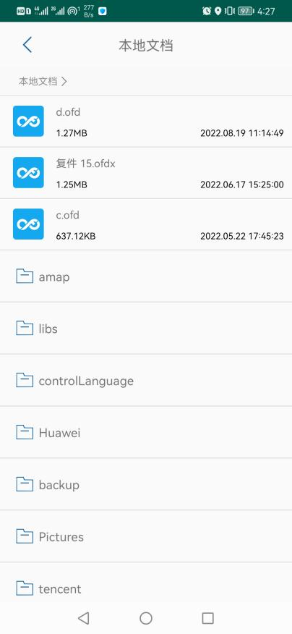

Fig.4-57 Select Document List

**5. Spread**

**5.1 Authorization**

**5.1.1 Personal Equipment Room**

"Propagation" controls whether the ofd file that can be propagated in a certain way can be opened by the recipient. The authorization between personal devices controls the form of file propagation. We can control what type of device the file can be propagated to and opened. The setting interface is as shown in the Fig.5-1.

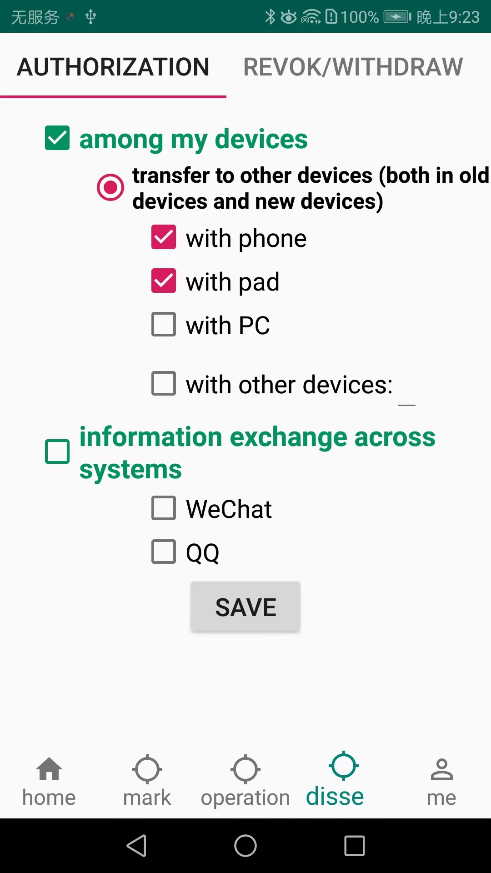

Fig.5-1 Setting propagation authorization

After filling in, click the "Save Settings" button.

Then come to the "File List" interface, click the "Select Document" button to select a document, as shown in Fig.5-2.

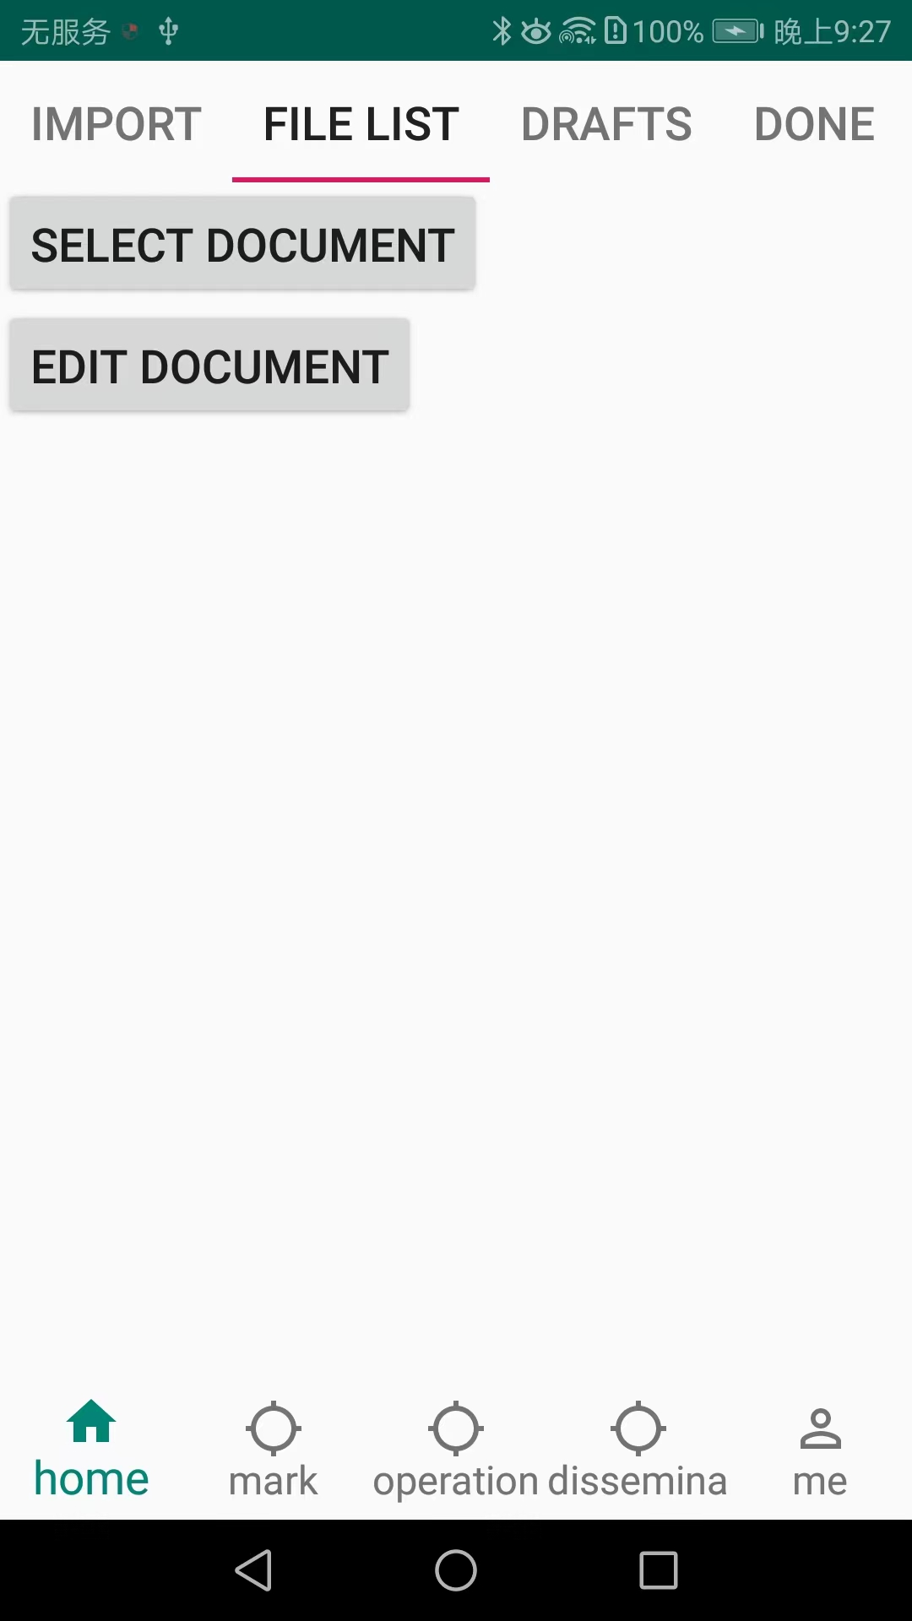

Fig.5-2 Begin to select documents

The interface for selecting a document is shown in Fig.5-3 . Select the document whose file name is " d.ofd ", and the interface after opening the document is shown in Fig.5-4 .



Fig.5-3 Select Document _

After opening the document, click the "Write Comment" button to write the propagation control we just set in the form of privacy control language . The writing result is shown in Fig.5-5.

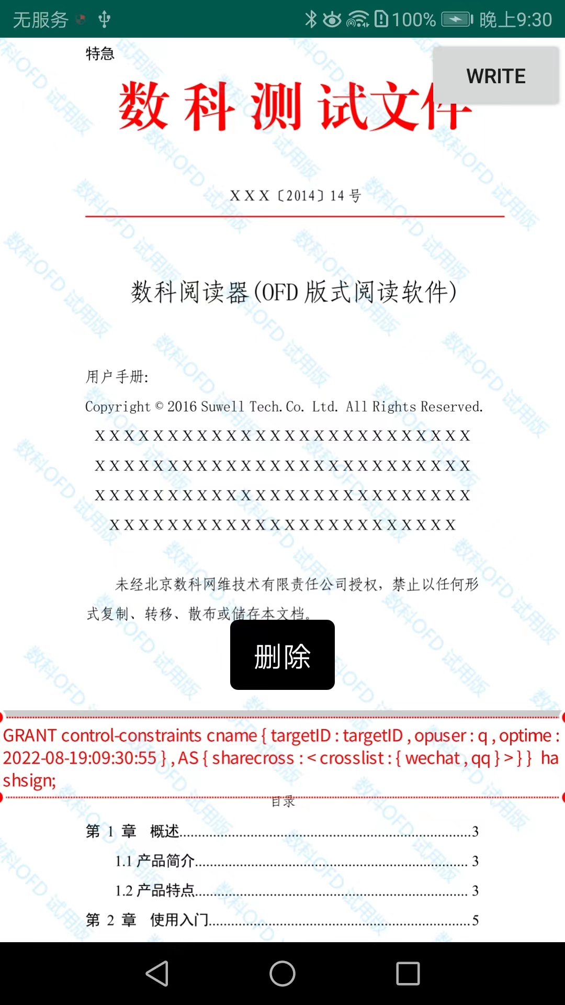

Fig.5-5 Write Control Language

We accept the document and open it through the mobile phone. Since we allow propagation to the mobile phone in the settings, the document can be opened normally, as shown in Fig.5-6.



Fig.5-6 Open the document normally

Return to the propagation constraint setting interface again and change the settings of the propagation constraint, as shown in Fig.5-7.

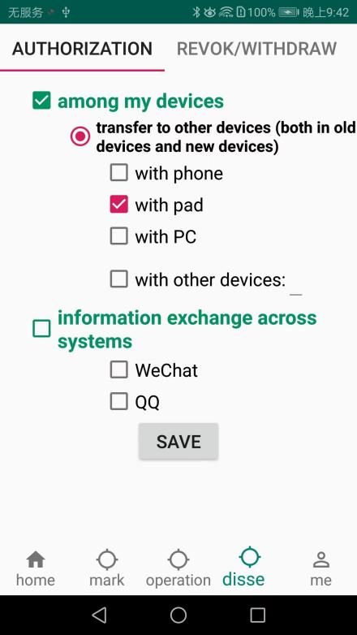

Fig.5-7 Setting propagation constraints

We send the document to the mobile phone and open the document through the mobile phone. Since the document cannot be transmitted to the mobile phone at this time, the file cannot be opened as shown in Fig.5-8, and the file cannot be opened.

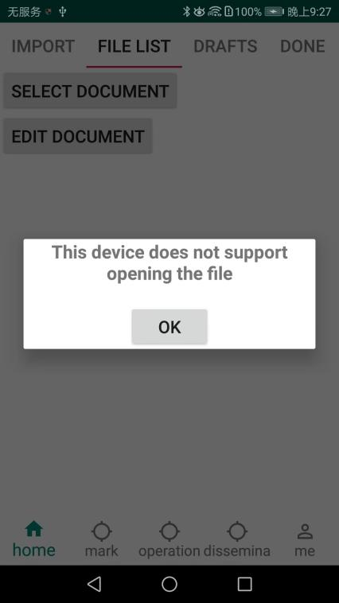

Fig.5-8 File can not be opened

**5.1.2 Exchange across information systems**

The dissemination control documents exchanged across information systems can be disseminated through which apps. The setting interface is shown in Fig.5-9.

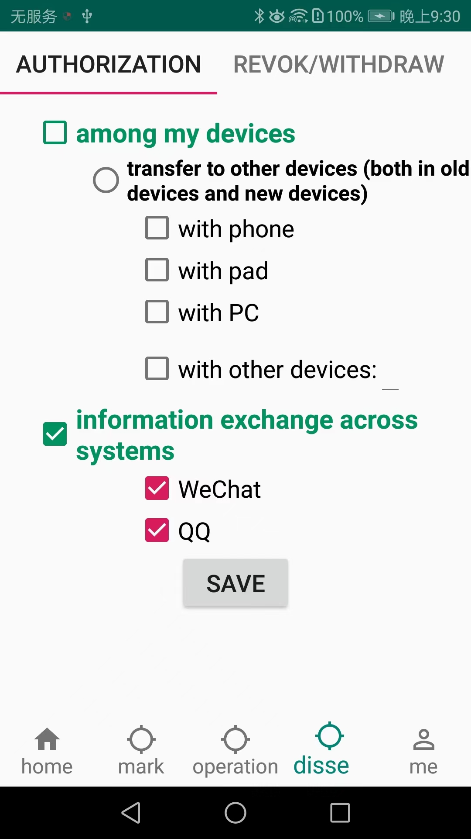

Fig.5-9 Setting propagation constraints

After filling in, click the "Save Settings" button.

Then come to the "File List" interface, click the "Select Document" button to select the document, as shown in Fig.5-10.



Fig.5 - 10 Begin to select documents

The interface for selecting a document is shown in Fig.5-11. Select the document whose file name is "qetg.ofd ".

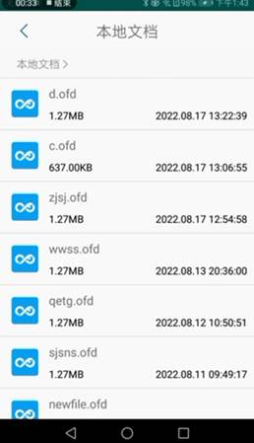

Fig.5-11 Select document _

The writing result is shown in Fig.5-12.



Fig.5-12 Write Control Language

Send the document to WeChat friends, and the recipient downloads and selects " sample.app " to open it, as shown in Fig.5-13 and Fig.5-14 .

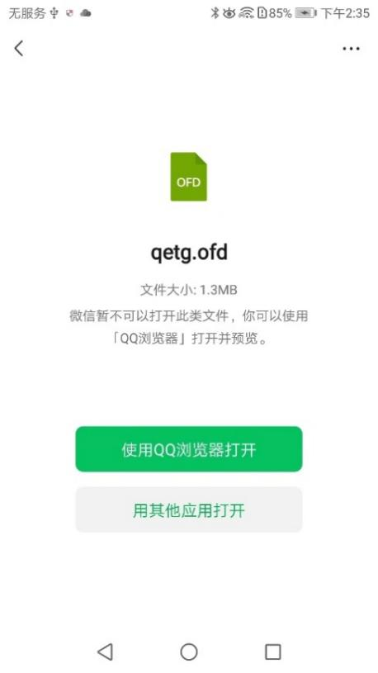

Fig.5-13 WeChat open _



Fig.5-14 Open the document normally

Return to the propagation constraint interface again, change the settings of the propagation constraint, and select "wwss .ofd" to write a comment, as shown in Fig.5-15.

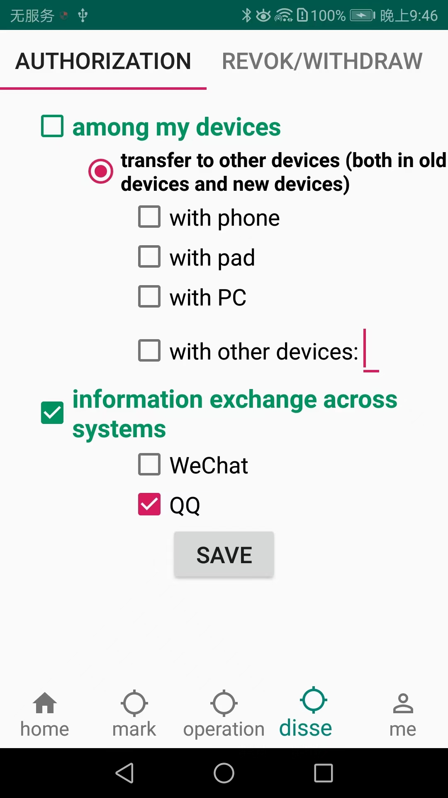

Fig.5-15 Setting propagation constraints

Send " wwss .ofd " to WeChat friends , the recipient will open the download and select other applications to open, as shown in Fig.5-16 .

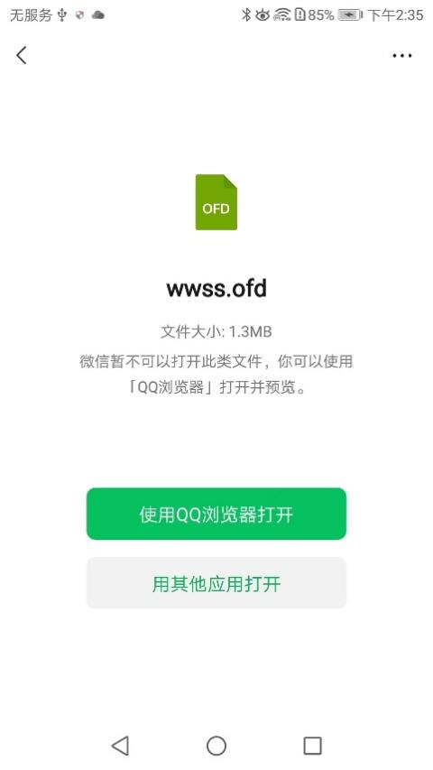

Fig.5-16 WeChat open _

At this time, the propagation constraint controls the ofd file propagated from WeChat, as shown in Fig.5-17, the file cannot be opened.

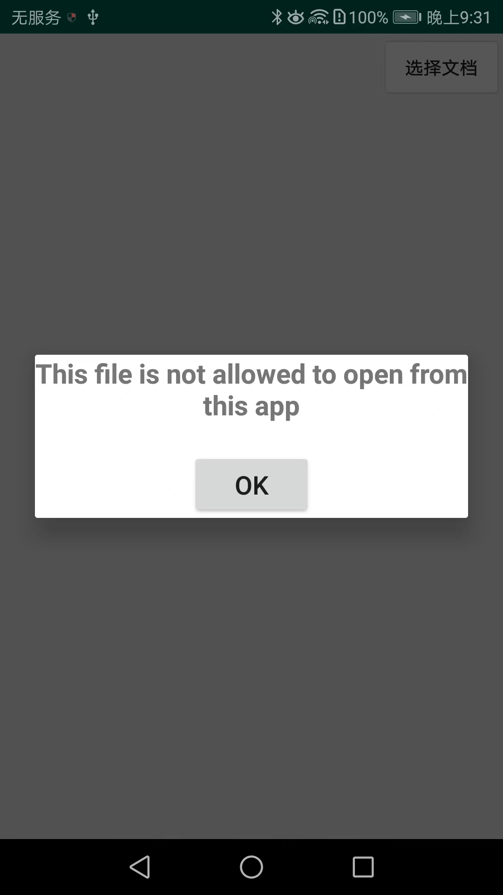

Fig.5-17 File can not be opened

**5.2 Authentication**

Authentication refers to judging what kind of authority a particular document has.

In the "File List" interface, click the "Select Document" button to select the document, as shown in Fig.5-18.



Fig.5-18 Begin to select documents

The interface for selecting a document is shown in Fig.5-19 . Select the document whose file name is " d.ofd ".



Fig.5-19 Select document _

After opening the document, go back to the "Authentication" interface, and click the button to authenticate the document's dissemination right, as shown in Fig.5-20 .

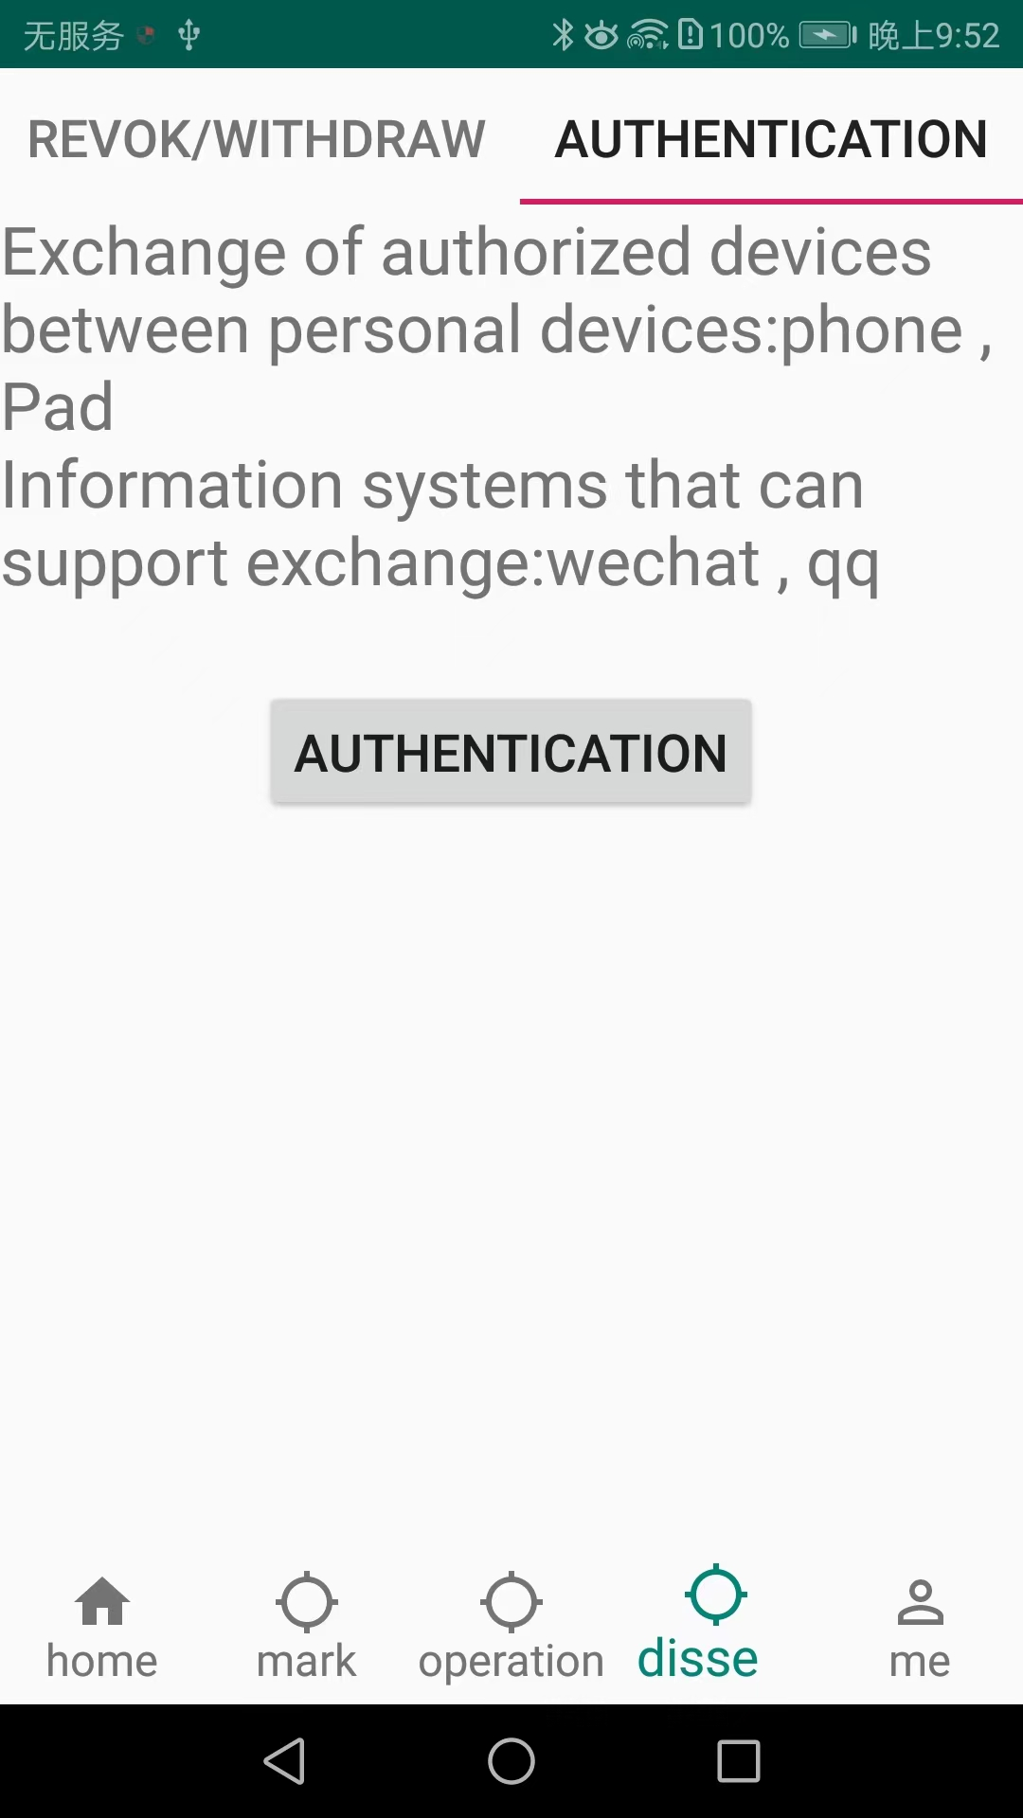

Fig.5-20 Authentication